Bulgarian Diploma Thesis

Comparing Coordination Mechanisms in Distributed Systems
Ivan Obreshkov, ID#200235036

Student: , Date:
signature

Supervisor: , Date:
signature

Department of Computer Science AUBG
Blagoevgrad 2025

Title: Comparing Coordination Mechanisms in Distributed Systems
Author: Ivan Obreshkov
Abstract: Distributed systems face the inherent challenge of coordinating state across unreliable networks. As applications scale, robust mechanisms for consensus, membership, and message ordering become critical. This thesis presents a comparative analysis and implementation of three coordination algorithms: Raft, Scalable Weakly-consistent Infection-style Process Group Membership (SWIM), and Fixed-Sequencer Total Order Broadcast (TOB). These mechanisms are evaluated against the CAP theorem, focusing on their trade-offs between Consistency, Availability, and Partition Tolerance. A modular Go-based framework was developed to implement each protocol. Raft provides strong consistency using bbolt for durable storage and gRPC for communication. SWIM offers scalable, eventually consistent membership via gossip over User Datagram Protocol (UDP). Fixed-Sequencer TOB achieves high-throughput atomic broadcast with total ordering guarantees through a dedicated sequencer. Rigorous benchmarks on a local testbed evaluated performance and scalability across cluster sizes of 3 to 9 nodes. Results show Raft ensures strong consistency but sacrifices write availability during instability, with linear message complexity. SWIM achieves O(1) scalability and high availability but offers only eventual consistency, ideal for failure detection. Fixed-Sequencer TOB delivers superior throughput and sub-millisecond latency but introduces a single point of failure, prioritizing consistency over partition tolerance. The thesis concludes that no single mechanism is universally optimal. Robust distributed architectures require a layered composition: SWIM for scalable membership, Raft for consistent control plane operations, and Atomic Broadcast for high-performance data replication.
Declaration of authorship:
“The Senior Project/Bulgarian Diploma Thesis presented here is the work of the author solely, without any external help, under the supervision of Narasimha Rao Vajjhala. All sources, used in development, are cited in the text and in the References section.”
Author: ______________________

Table of Contents
1. Introduction 5
1.1. Motivation 5
1.2. Project Overview 6
2. Specification of the Software Requirements and their Analysis 7
2.1 Functional Requirements 7
2.1.1 Common to all mechanisms 7
2.1.2 Raft Functional requirements 8
2.1.3 SWIM Functional requirements 9
2.1.3 Fixed-Sequencer TOB Functional requirements 9
2.2 Non-Functional Requirements 9
2.3 Analysis of Functional Requirements 10
2.3.1 Safety and Consistency 10
2.3.2 Liveness and progress 12
2.3.3 SWIM Membership 12
2.3.4 SWIM dissemination cost 13
2.4 Analysis of Non-Functional Requirements 13
2.4.1 Performance 13
2.4.2 Scalability 14
2.4.3 Maintainability 14
2.4.4 Maintainability 15
3. Design of the Software Solution 15
3.1 Raft 15
3.1.1 Raft compared to other consensus algorithms 15
3.1.2 Raft’s inner workings 19
3.2 SWIM 29
3.2.1 SWIM compared to other algorithms 29
3.2.2 SWIM’s inner workings 31
3.3 Fixed-Sequencer Total Order Broadcast (TOB) 35
3.3.1 Fixed-Sequencer TOB compared to other algorithms 35
3.3.2 Fixed-Sequencer TOB inner workings 38
4. Implementation 43
4.1 Raft 43
4.1.1 External Dependencies 43
4.1.2 Custom Pub/Sub Architecture 44
4.1.3 Architectural Components 44
4.2 SWIM 45
4.2.1 External Dependencies 45
4.2.2 Architectural Components 46
4.3 Fixed-Sequencer TOB 47
4.3.1 External Dependencies 47
4.3.2 Architectural Components 47
5. Benchmarks 48
5.1 Raft Benchmarks 48
5.1.1 Raft Performance Analysis (NFR1) 48
5.1.2 Raft Scalability Analysis (NFR2) 51
5.2 SWIM Benchmarks 53
5.2.1 SWIM Performance Analysis (NFR1) 53
5.2.2 Scalability Analysis (NFR2 & FR6) 55
5.3 Fixed-Sequencer Total Order Broadcast (TOB) Benchmarks 56
5.3.1 Fixed-Sequencer TOB Performance Analysis (NFR1) 57
5.3.2 Fixed-Sequencer TOB Scalability Analysis (NFR2) 57
5.4 Future Work 58
6. Results and Conclusion 58
6.1 Raft: Strong Consistency at the Cost of Availability 58
6.1.1 CAP Theorem Analysis 58
6.1.2 When to use Raft 59
6.2 SWIM: High Availability and Scalability 59
6.2.1 CAP Theorem Analysis 59
6.2.2 When to Use SWIM 60
6.3 Fixed-Sequencer TOB: Throughput and Total Order 60
6.3.1 CAP Theorem Analysis 60
6.3.2 When to Use Atomic Broadcast (Total Order Broadcast) 61
References: 62

Table of Figures
Figure 1: Handling of RequestVote RPC 22
Figure 2: Handling of AppendEntries RPC 26
Figure 3: Raft Membership changes 28
Figure 4: SWIM direct and indirect probe 32
Figure 5: SWIM suspicion lifecycle 34
Figure 6: Sequencing Flow 40
Figure 7: Fixed-Seqencer TOB State Machine 42
Figure 8: Raft Class Diagram 45
Figure 9: SWIM Class Diagram 46
Figure 10: Class Diagram Fixed-Sequencer TOB 47

1. Introduction

1.1. Motivation
Recently I have been playing around with orchestration tools such as Docker Swam [1], and while I was reading the docs, I came up to the fact that Docker Swarm uses Raft under the hood [2], and that’s how I learned about one of the algorithms I will be implementing.
To be honest, I have always been fascinated by Distributed Systems, and have always wondered about their inner workings, for example how database replication happens. This is what motivated me to write this thesis, to understand more about the different mechanism used in Distributed systems, and when to use each of them to solve common problems that often occur (e.g., consensus).

1.2. Project Overview
The aim of this project is to implement and compare three foundational coordination mechanisms used in Distributed Systems:
- Consensus - this mechanism is used to ensure all nodes in the cluster agree on a single value. For the implementation, I will be using Raft [3],
- Atomic broadcast - this mechanism guarantees all messages are delivered to all nodes in the same order. For the implementation, I will be using a Fixed-Sequencer Total-Order Broadcast (TOB) protocol. [4]
- Cluster membership and member failure detection. For the implementation, I will be using Scalable Weakly-consistent Infection-style Process Group Membership (SWIM) [5].
Each of these protocols will be discussed in more detail in Section 3.

The comparison focuses on the consistency models that each mechanism’s safety/consistency guarantees, liveness/progress under failures, performance (latency/throughput), and protocol overhead (CPU, memory, and network). The goal is not to declare a universal “winner”, as each mechanism has a different role, but to illustrate where each mechanism is appropriate, given tradeoffs in the context of the CAP theorem (Brewer's theorem) [4] and performance requirements of each system.

The project is written in Go [6] for several reasons. Go is a highly performant, statically typed, compiled language, which is also garbage collected. The main reason I chose this language is that it is widely used in many DevOps tools, such as Kubernetes [7] and Docker [8]. It also provides easy-to-use concurrency paradigms (e.g., goroutines and channels), which are essential for use cases such as managing a cluster of Nodes. For example, channels provide a native way to implement a signaling system. Goroutines are essentially Green threads, and they allow us to handle each request in a new goroutine, preventing the main one from blocking, during an I/O bound operation, such as reading from disk.

The application is written with the five key object-oriented design principles (SOLID) [9] in mind, but it does not follow the traditional Object-Oriented Programming (OOP) principles, such as inheritance, just because Go is not an OOP language itself. Instead Go, it promotes “composition over inheritance” [10], which clearly describes dependencies between different components of the code, and facilitates easier testing with techniques such as Mocking. The project’s architecture is mainly event-driven due to the nature of cluster orchestration and maintaining the desired state of the system, but it also promotes a highly decoupled design, which is easier to maintain and reason about.

2. Specification of the Software Requirements and their Analysis

2.1 Functional Requirements

2.1.1 Common to all mechanisms
FR1 - Safety and consistency (baseline for all mechanisms)
The system must never produce conflicting results. For Raft this means that the replicated log does not diverge between different nodes. Meaning if two nodes look at the same log index, they would see the same entry. This also means that a committed entry never changes.
For SWIM this means the view of which nodes are alive or dead in the cluster does not get stuck in the wrong state. For example, if a node crashes, first it might be treated as alive for some time, but eventually it will be treated as dead (failed). The crashed node will not stay in the alive state forever.

For Fixed-Sequencer TOB this means every node delivers exactly the same set of messages in exactly the same order, with no duplicates.

FR2 - Liveness and progress (baseline for all mechanisms)
The system must keep making progress under normal conditions. There might be a temporary window where normal conditions are disrupted, and progress halts, but once these conditions for the respective mechanism are restored, the system continues making progress.

Normal conditions are assumed to be healthy and running nodes, and a reliable Local Area Network (LAN). The disruptions are assumed to be crash-stop failures of nodes, and eventually reliable LAN, meaning packets could sometimes be delayed, reordered or dropped, and there might be times where a network partition happens, but eventually connectivity is restored.

2.1.2 Raft Functional requirements
FR3 - Consensus semantics
A log entry (command) is considered committed only after the majority of servers have stored it in their logs. Every server eventually applies the commands from its log to its state machine, in the same order, so the whole replicated state machine stays in sync. All commands sent from clients are sent to the leader. If a command is sent to a follower, the command gets forwarded to the leader.

FR4 - Leadership and elections
At any given term must be at most one leader. If the leader node stops or there is a network partition and the leader is unreachable, a new leader is elected within a bounded time, assuming the majority of servers can talk to each other.
There might be a situation where a split vote occurs during an election, meaning the votes are equally spread between candidate nodes. Randomized election timeouts must resolve tie votes quickly so only one candidate eventually wins and becomes a leader. Servers that receive messages containing a newer term, step down to followers to avoid having two leaders at once.

2.1.3 SWIM Functional requirements
FR5 - Membership semantics
Each node that has crashed will eventually be marked as “failed” by the whole cluster, and each node that is alive but marked as “suspected”, will eventually be marked as alive again, assuming it answers to a ping before a suspicion timeout expires.
FR6 - Dissemination cost
The network load and the gossip work that each node does, must remain roughly constant as the cluster size grows.

2.1.3 Fixed-Sequencer TOB Functional requirements
FR7 - Total order and integrity
All alive nodes deliver exactly the same set of broadcasts and in exactly the same order. There are no duplicate broadcasts, and nothing is delivered that was never broadcasted.
FR8 - Sequencer availability
A single sequencer assigns the global order. In this project the sequencer is fixed for a run. If the sequencer is down or unreachable, ordering stops.

2.2 Non-Functional Requirements
NFR1 - Performance
Provide measurable latency (p50/p95) and throughput per mechanism under a controlled localhost testbed.

NFR2 - Scalability
The system must run correctly and predictably as the cluster grows to N ∈ {3, 5, 7, 9}. Provide measurements om how latency, throughput, and message load change with N.

NFR3 - Maintainability
The implementation must be written in Go, with clear modular separation between state management, transport, and storage components. The codebase should include unit tests achieving at least 80 % coverage for core behaviors for each mechanism.

NFR4 - Observability
The system must provide clear log output for major events such as elections, commits, crashes, and recoveries. Logging and metrics should be sufficiently detailed to support debugging and performance evaluation.

2.3 Analysis of Functional Requirements
The requirements that are not mentioned in this section do not require any type of deeper analysis.

2.3.1 Safety and Consistency
This section addresses FR1.

Raft defines a set of properties to ensure Safety. Each of these properties is guaranteed to be true at all times by the protocol. As mentioned in Figure 3 in the Raft paper [3], they are as follows: there must be at most one leader node per term (a type of logical clock [11] used by nodes in the cluster to detect obsolete info, such as stale leaders); leaders never overwrite committed entries; if an entry has been committed for a given term, the newly elected leader node will have access to it. These properties are maintained under all non-Byzantine conditions, including message reordering or delays, assuming failures are limited to simple crash-stop behavior. These propertires have also been formally proven in the paper [3]. By persisting state to disk and employing majority quorums for every decision, Raft effectively becomes deterministic.

In contrast, the Fixed-Sequencer TOB protocol adopts a more relaxed definition of safety, focusing on message ordering rather than state replication. It guarantees uniform total order, meaning that all alive nodes deliver the same set of messages in exactly the same order. It also guarantees integrity, ensuring that no message is delivered more than once and that only messages actually broadcast are ever delivered. Safety violations can only occur if multiple sequencers exist simultaneously or if nodes deliver messages out of order. Because this implementation has exactly one sequencer per run, there is no risk of multiple sequencers running at the same time. The risk of out of order delivery is addressed by buffering and sequence validation mechanisms. Finally, because TOB does not persist messages to durable storage by default, it cannot guarantee that messages will survive a complete system restart. Thus, its safety comes to consistency of delivery, not to persistence of state.

The SWIM protocol presents a totally different safety profile. Its design prioritizes scalability and continuous operation over absolute correctness, resulting in what can be described as statistical safety. SWIM’s fundamental safety guarantees are completeness - the assurance that every crashed node will eventually be suspected by all correct nodes. and accuracy - the assurance that no correct node will remain falsely suspected forever. These properties are probabilistic rather than deterministic: under high network latency or a prolonged network partition, SWIM may incorrectly suspect healthy nodes. This phenomenon, known as a false positive, is a well-documented limitation of gossip-style failure detectors [12].

2.3.2 Liveness and progress
This section addresses FR2.

Under the assumptions mentioned in Section 2.1.1 (healthy nodes, reliable LAN), during normal conditions, Raft makes progress when a majority of nodes can reach each other and a leader can be elected. SWIM makes progress when gossip messages are flowing so suspicions and confirmations of dead nodes can spread to other nodes. The Fixed-Sequencer TOB makes progress when the sequencer process is up and running.

In case of a network partition, for example, progress might halt, but after the disruption ends each mechanism resumes processing work within bounded time determined by its timeouts and retry intervals.

2.3.3 SWIM Membership
The transition of a node from and alive state to a failed state, happens gradually. This means that after a ping has been sent, and no ack has been received from the target node, within a bounded time, then the pinger will ask a fixed number of other nodes to indirectly ping the target. If again no ack message has been received the target is then marked as “suspected”. After a suspicion timeout expires, and no communication has been received from the suspected node, it will eventually be marked as failed by the whole cluster.

If a healthy node has been suspected, for example due to a network partition, and the node communicates withing the suspicion timeout, the suspicion will eventually be refuted by the whole cluster. The protocol does not guarantee a specific time for detection or refutation. It guarantees that the whole cluster view will eventually converge as messages continue to flow between nodes.

2.3.4 SWIM dissemination cost
This section addresses FR6.

As mentioned above if a direct ping to a node times out, then the pinger node asks a small, fixed number of peers (k) to ping the target on behalf of it. Because k is a constant and the ping period is fixed, the number of messages a node sends and receives per period does not grow with the cluster size. [5]

Each ping and ack message carries a small digest of recent membership updated with at most c items, so the amount of data a node merges per period is also constant and does not change as the cluster grows. As a result of these two bounds – k and c, the network load and the work done by each node stay roughly constant, while the total traffic across the whole system increases in proportion to the number of nodes.

2.4 Analysis of Non-Functional Requirements

2.4.1 Performance
This section addresses NFR1.

Performance is evaluated as end-to-end latency (p50/p95) and sustained throughput under a controlled localhost testbed. Raft is expected to show higher write latency because a majority of nodes must acknowledge each write operation before a log entry is considered committed. Throughput mostly depends on the leader’s fan-out capacity and the underlying storage option. In the Fixed-Sequencer TOB path, latency is lower because the single sequencer only assigns sequence numbers to messages and then broadcasts them to the rest of the nodes. Throughput is limited by the sequencer’s outbound bandwidth. For SWIM, the time of view convergence is measured, meaning the time it takes for every node in the cluster to find out about a failure of a node for example. The per-node overhead stays nearly constant as the cluster grows.

2.4.2 Scalability
This section addresses NFR2.

Scalability describes how resource use and performance change as the cluster grows to N ∈ {3, 5, 7, 9}. In Raft, each write needs a majority, so adding nodes increases the work to commit and throughput usually drops as N grows. In the Fixed-Sequencer TOB, one sequencer sends each message to every node, so latency is low in small clusters, but as N increases the sequencer’s network bandwidth becomes the bottleneck, assuming we are not running on localhost. This is tracked by measuring per-node send and receive rates. In SWIM, each node does roughly constant work per ping round. The system as a whole, though, generates more messages as N grows. Convergence time increases slowly with N because peers are chosen at random and indirect probes add extra hops.

2.4.3 Maintainability
This section addresses NFR3.

Maintainability is achieved through a modular Go implementation that separates transport from protocol state. The transport layer is an abstraction over how the communication happens between the nodes in the given algorithm (e.g. Remote Procedure Calls in Raft). The protocol state is managed in a different layer. This allows for separation of concerns and testing each layer in isolation. I use an event-driven approach to further decouple different parts of the project.

2.4.4 Maintainability
This section addresses NFR4.

Observability requirements are met by structured logs and lightweight metrics exported per node. For Raft, logs include term changes, vote outcomes, commit indices, etc.., metrics report command commit latency, number of requests, and election counts. For total-order broadcast, logs record sequence assignment and delivery, For membership, logs trace probe outcomes and suspicion/refute events. Metrics report ping latencies, propagation latencies and counts of events such as suspicions.

3. Design of the Software Solution

3.1 Raft

3.1.1 Raft compared to other consensus algorithms
There are many algorithms for achieving consensus in a distributed environment. The three main ones often mentioned in literature are Raft [3], Paxos [13], [14], and Viewstamped Replication (VR) [15]. It is important to note that these algorithms are designed for achieving consensus across nodes that we control. There are cases where we need to operate in a zero-trust environment, where a Byzantine fault-tolerance (BFT) algorithm is required. A good example is the algorithm used by Bitcoin, namely Proof-of-Work [14]. This project will not examine BFT algorithms, as they are out of scope.
I chose Raft over Paxos and VR for two main reasons. Raft is currently one of the most widely adopted consensus algorithms in major tools and production systems. Some of them include etcd [16], CockroachDB [17], and Consul [18]. It is also easy to understand when compared to the rest, and that was the goal of Ongaro and Ousterhout when they published the paper in 2014.

When comparing Raft and Paxos, their goal is the same: to achieve consensus. Actually, as stated in the paper, Raft was designed to produce the same outcomes as (multi-)Paxos and achieve this with the same efficiency as a single-degree Paxos, but with a structure that was easier to understand, implement, and reason about. The original Paxos (single-degree Paxos) protocol tries to achieve consensus on a single value. (Multi-)Paxos, on the other hand, uses multiple instances of the single-degree Paxos to achieve consensus on a sequence of values rather than a single value. I will mostly use single-degree Paxos for comparison, as there is no uniformly agreed implementation for a (multi-)Paxos [1].

Ongaro and Ousterhout used problem decomposition to make the different parts of the protocol more decoupled and easier to reason about. They divided Raft into leader election, log replication, safety, and membership changes. They also reduced the system’s overall possible states, which made it more deterministic.

Besides the understandability dimension, Raft differs from Paxos on a structural level as well. Raft adopts a so-called strong leadership, meaning only one leader appends to the log, and the flow of data is always from the leader node to the rest of the nodes. If a client’s request hits a non-leader node, the request is forwarded to the leader.

In comparison, Paxos is inherently symmetric at its core. This means that any node is allowed to make a proposal for a given value, to be aggregated upon by the rest of the nodes. The algorithm does not privilege one node over the others. This symmetry, though, prevents safety. If two nodes start proposing at the same time, there is a chance of a collision between the proposed values that the cluster has to agree upon. This causes retries and extra messages exchanged between the nodes, which wastes both time and bandwidth. In order to guarantee progress, Lamport proposes that a single leader (distinguished proposer) should be implemented as a separate layer on top of the Paxos protocol [12]. Raft, by contrast, makes exclusive leadership a first-class citizen, which makes log matching rules easier to implement and understand.

Leader establishment also differs. In Raft, elections are again built into the algorithm. Each election starts after a randomized election timeout window. A node transitions from a follower state to a candidate, and starts sending requests to other nodes in the system. The node that has gathered the majority of the votes wins the election and becomes the leader node. Majority is defined as floor((N/2)+1), where N is the number of nodes in the cluster. In comparison, the core Paxos protocol assumes a way to obtain a leader but does not standardize an election mechanism.

Finally, Raft integrates cluster reconfiguration (membership changes) as part of the algorithm. This is done via a so-called joint consensus approach. This means that during a change (e.g., a new node joins the cluster), both the old configuration and the new configuration are active at the same time, to ensure a smooth and safe transition between states. This will be explained in more detail in the sections that follow. Paxos has reconfiguration mechanisms (e.g., Vertical Paxos [19]), but there is no single canonical approach in the core Paxos protocol.
The fact that Paxos is quite ambiguous when it comes to topics such as leader election and that it requires so much overhead and external modules to implement it properly often makes Raft the de facto standard for many modern production systems, including this project itself.
Viewstamped Replication’s design is actually much closer to that of Raft, rather than Paxos. Both are leader-based algorithms for managing a replicated state machine [20]. In fact, the terms used by the two protocols are directly mapped to each other: Raft’s leader corresponds to primary in VR’s context; Raft’s (term, index) pairs correspond to VR’s viewstamps/op-numbers; and both protocols ensure that a newly elected coordinator is sufficiently up-to-date before it can persist new log entries (commands) to its log (a persisted sequence of commands). There are, however, differences in presentation and mechanism details.

One difference is in the election mechanism. As mentioned above, Raft uses randomized election timeouts to trigger a new election process. It is baked into the algorithm and intentionally simple. VR on the other hand uses a separate so-called view change protocol. Functionally they both achieve the same goal, but VR’s implementation adds overhead and complexity.

Another difference is how the new leader’s log is kept up to date. Raft prevents a stale server from becoming leader by requiring voters to grant a vote only to a candidate whose log is at least as up to date as their own. This rule ensues that the elected leader already contains all committed log entries. In contrast, VR may choose a new primary that is initially missing some committed entries, and then repairs the gap during the view change by collecting state from replicas and installing the most recent log. Functionally both converge, but Raft avoids this extra catch-up machinery by baking leader-completeness into the election itself.

The advantage that VR has over Raft is that VR can run without a stable storage, whereas Raft explicitly requires one. This advantage is extremely useful in situations where we have special requirements for stable storage, for example when developing a database. A good example is Tigerbeetle [21]. It uses VR for replication and pairs it with a Protocol-Aware Recovery [22] to protect against storage faults, as mentioned in their design document [23].

The simplicity of Raft though outweighed this advantage of VR for the use cases of this project. While Raft is fairly simple to understand it is by no means simple to implement. The first implementation of Raft is around 2000 lines of source code [24]. That said, now lets explain in more detail how Raft works.

3.1.2 Raft’s inner workings
All of the information in this section is derived from Ongaro and Ousterhout’s work [3].
Raft has divided its functions into three main categories: Leader Election, Log Replication, and Membership changes. Before going through each category, it is important to understand the terminology used in the protocol. Each node, at any given time, could be one of these three states: leader, follower, or candidate. While the cluster operates normally, there is always exactly one leader, and the rest of the servers are followers. The leader is responsible for handling client requests. If a client hits a follower node, the request is forward to the leader node. A node could be in a candidate state only when an election process is undergoing. The communication between nodes happens via Remote Procedure Calls (RPCs). The two core RPCs in Raft are RequestVote and AppendEntries. RequestVote is used during the election process. AppendEntries is used during normal operation of the cluster, primary for Log Replication and liveliness detection of the leader.

As nodes communicate over a network, a given request could be dropped or arrive later due to a congestion in the network. It is important that we keep track of when each request has been sent in order to preserve some kind of ordering of events. Usually this is achieved via a so called Lamport clocks [11]. This is a simple logical counter where each process keeps in order to assign timestamps to its events so that the system can agree on an order of events without relying on synchronized physical time. Ongaro and Ousterhout use such mechanism in Raft, but they use the notion of an election term, for this counter. The term starts from 0 when the cluster boots and increases monotonically after that.

Each node maintains a timer, which tracks the so called election timeout. The time for the election timeout is chosen randomly for each node. The authors suggest a randomly chosen value between 150ms and 300ms. This is the mechanism responsible for triggering the election process. Periodically each leader is responsible for sending a heartbeat (empty AppendEntries RPC) to all followers in the cluster. If a follower does not receive a heartbeat within this election timeout period, it assumes that the leader node is dead, for whatever reason (e.g. the node has stopped, or a network partition has occurred), and triggers an election. An important note is that the election timeout is bound to a given term, meaning that for every new term, a new election timeout is chosen.

The election process is as follows. When a follower’s election timeout expires it increments its term, transitions to a candidate state, votes for itself and sends RequestVote RPCs to its peers. It is possible that there exists more than one candidate in a given term, during the election process. The RequestVote RPC, as the name implies, is used to request a vote from a given server. Each RequestVote RPC carries the candidate’s current term, the candidateId, and a summary of the candidate’s log - lastLogIndex and lastLogTerm - so the voter can apply the “up-to-date” rule. The up-to-date rule means that when a follower server receives a RequestVote RPC from a candidate, it will grant its vote only if the candidate’s log is at least as up-to-date as its own. Raft defines “at least as up-to-date” lexicographically by (lastLogTerm, lastLogIndex):
- If the candidate’s lastLogTerm is greater than the voter’s, the candidate is considered up-to-date (vote may be granted), regardless of index.
- If the lastLogTerm is equal, then the candidate’s lastLogIndex must be greater than or equal to the voter’s.
- Otherwise, the vote is denied.
The schemas of the RequestVote RPC request and response payloads are shown in Code Fragment 1. The handling flow of a RequestVote RPC is shown in Figure 1.
// RequestVote RPC — Request (from candidate to voter)
message RequestVoteReq {
term : int // candidate’s current term
candidateId : ServerID // who asks for the vote
lastLogIndex : int // candidate’s last log index
lastLogTerm : int // candidate’s last log term
}

// RequestVote RPC — Response (from voter to candidate)
message RequestVoteResp {
term : int // voter’s current term (for candidate to update)
voteGranted : bool // true if voter grants its vote
}
Code Fragment 1
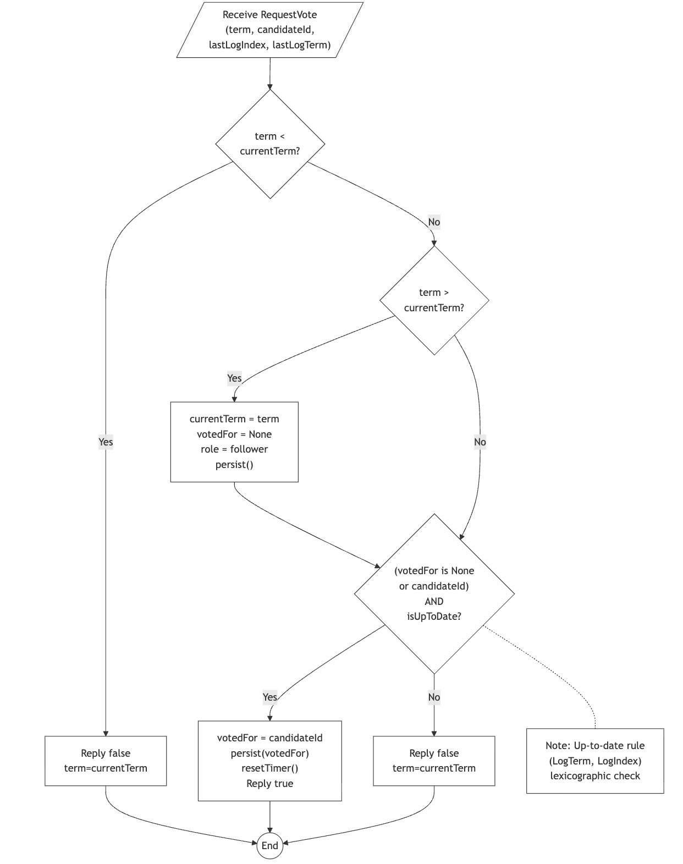
Figure 1: Handling of RequestVote RPC

A candidate becomes a leader and wins the election when it has gathered the majority of votes. A split vote is possible, meaning no candidate achieves a majority, but this quickly gets resolved, as the election timeout of the candidate for the new term expires, and a new election is triggered for the next term. After a candidate has won the election and has transitioned to a leader state, its starts sending heartbeats to is peers, in order to establish its authority.

An important note when a server handles all types of RPCs. It critically checks its current term versus the term that is included in the RPC. If the current term of the node is > than the term in the RPC, then the request is rejected. If the incoming RPC has a term > than the current term of the server, the server updates its current term to the higher value and steps down to a follower state. And finally, if a node receives a heartbeat, while it is in a candidate state, with a term >= than the current term of the candidate, the candidate recognizes the leader node, and steps down to follower.

Now that we understand how the election process works, we should move on to the Log replication process. Once a node has become a leader, it starts handling requests from clients. Each request contains a command to be executed by the state machine of a given node. Before execution, the command is appended to the log of the leader node. This log then gets replicated to the other nodes in the cluster, and finally, once the log has been successfully replicated, each node’s state machine processes the entries from the log one by one, and the leader responds to the client. Raft guarantees that once a log has been replicated, it is durable and will eventually be executed by all available state machines. Because every server applies the same ordered sequence of committed commands, the system behaves like a single replicated state machine [20].

In more detail, each AppendEntries RPC carries the leader’s term and id, the consistency anchor (prevLogIndex, prevLogTerm), a (possibly empty) array of new entries, and the leader’s current leaderCommit index. Schemas of the AppendEntries RPC, request, and
// AppendEntries RPC — Request (from Leader/Sequencer to Follower)
message AppendEntriesReq {
term : int // leader’s current term
leaderId : ServerID // so follower can redirect clients
prevLogIndex : int // index of log entry immediately preceding new ones
prevLogTerm : int // term of prevLogIndex entry
entries[] : LogEntry // log entries to store (empty for heartbeat)
leaderCommit : int // leader’s commit index
}

// AppendEntries RPC — Response (from Follower to Leader/Sequencer)
message AppendEntriesResp {
term : int // follower’s current term (for leader to update)
success : bool // true if follower contained entry matching prevLogIndex and prevLogTerm
}
response payloads are shown in Code Fragment 2.
Code Fragment 2

A follower accepts the RPC only if its own log has an entry at prevLogIndex whose term equals prevLogTerm; otherwise, it replies failure. The leader then backs up to an earlier prevLogIndex and retries until it finds a match, after which it sends the missing suffix. This “find a common prefix, then append the rest” rule enforces Raft’s log-matching property and repairs divergence caused by crashes or leadership changes.

On success, the follower appends any new entries and acknowledges; the leader updates, for that follower, nextIndex[i] (the next index to send) and matchIndex[i] (the highest index known replicated on that follower). Heartbeats (AppendEntries with no entries) still carry leaderCommit, so followers learn about newly committed entries even when there is no fresh data to append.

An entry becomes committed when it is stored on a majority of servers and the leader advances its commitIndex. To preserve safety across leadership changes, a leader advances commitIndex only for entries from its current term once it observes a majority for those entries; earlier entries become committed as a consequence. After commitIndex moves forward, the leader (and then the followers) apply all entries up to that index to their state machines in order. The leader replies success to the client only after the entry is committed, which yields linearizable behavior with respect to the leader. The handling flow of an AppendEntires RPC is shown in Figure 2.
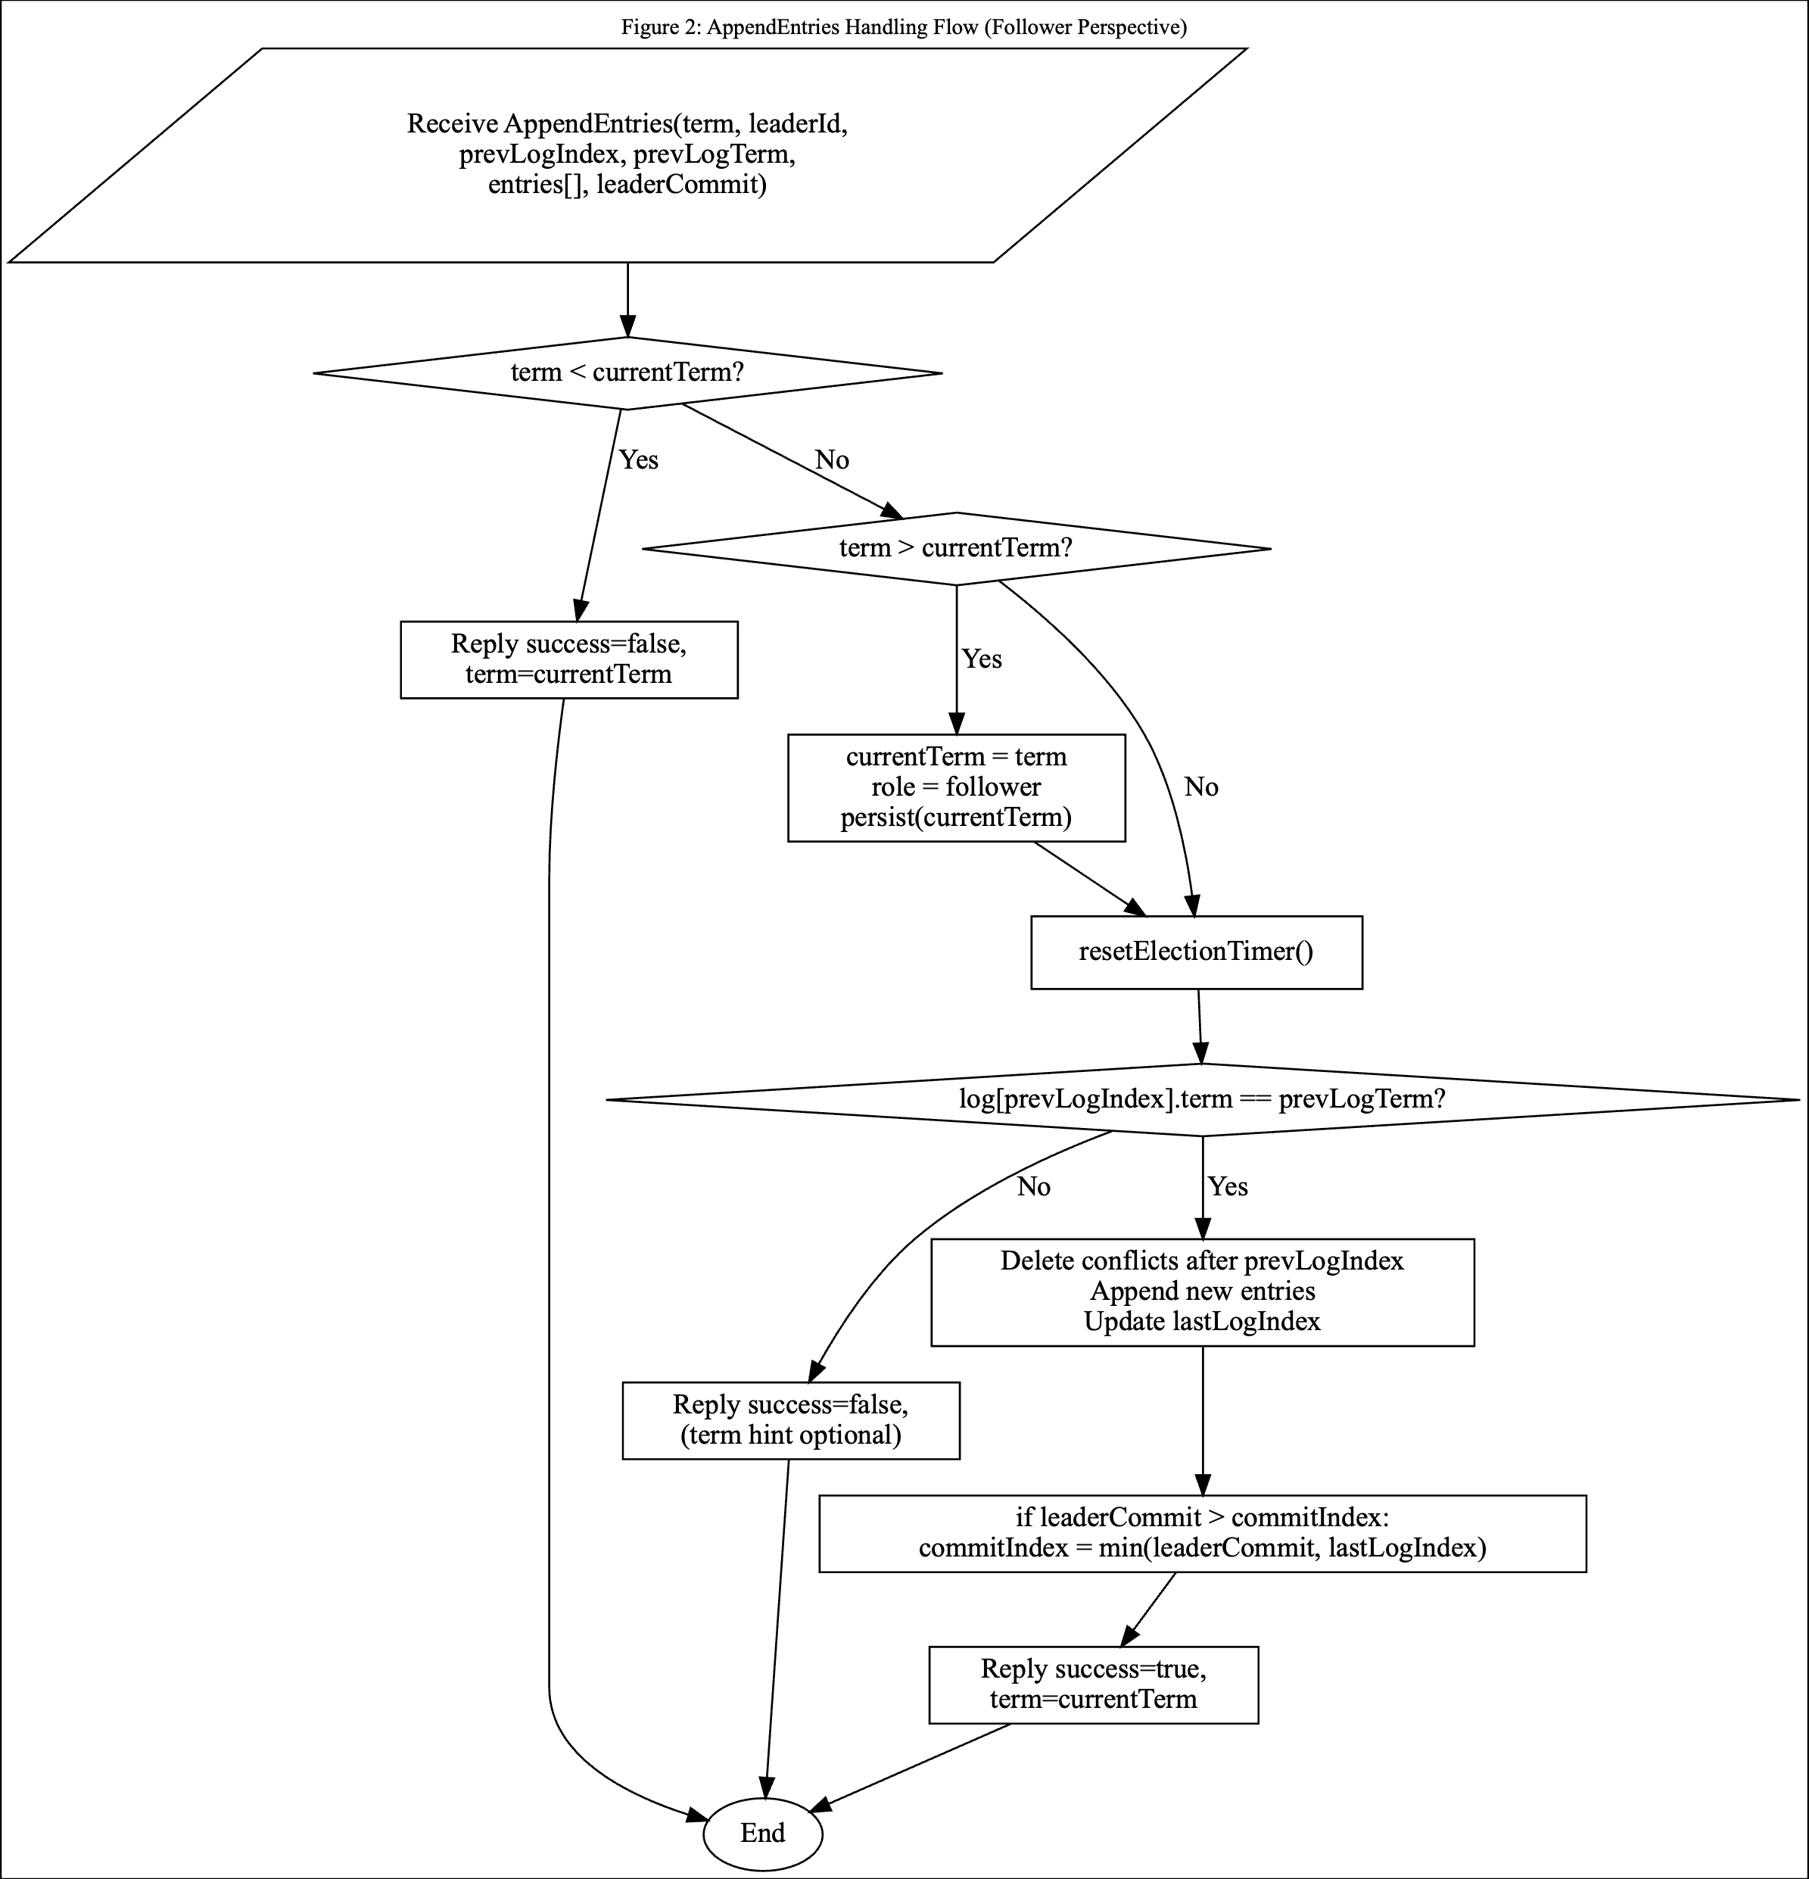
Figure 2: Handling of AppendEntries RPC

About Membership Changes. Raft allows the cluster to change its voting set without stopping. A direct jump from the old set to the new set can be unsafe, because the two majorities might not overlap and two different leaders could make conflicting decisions. To avoid this, Raft passes through a short joint consensus phase in which both the old and the new sets participate. While the joint configuration is active, every log entry (including the final configuration change) must be accepted by a majority of the old set and a majority of the new set. These two majorities necessarily overlap, which carries one consistent log across the handoff and prevents split-brain. After the joint step is committed, the cluster moves to a new-only configuration and continues as normal.

In practice, the change is driven entirely by log entries. The leader first appends a configuration entry that contains the union of old and new members. While this entry is the latest configuration in a server’s log, that server uses the joint rule for both commitment and voting. Ordinary AppendEntries replication applies. Followers who receive the joint entry record it in their logs and begin using the joint rule as soon as it becomes their latest configuration. Each server always applies the quorum rule indicated by the latest configuration entry in its own log, and the usual consistency checks (prevLogIndex, prevLogTerm) move all servers toward the same view.

Once the leader observes that the joint entry is committed, it appends a second configuration entry that lists only the new set. When the new-only entry is committed, all servers switch to using only the new members for elections, voting, and quorums. If the current leader is not part of the new set, it completes the change and then steps down immediately after the new-only entry commits; a leader from the new set will be elected. Configuration entries are replicated and committed like any other entries, so they have the same ordering and durability properties. The overall membership-change flow is illustrated in Figure 3.

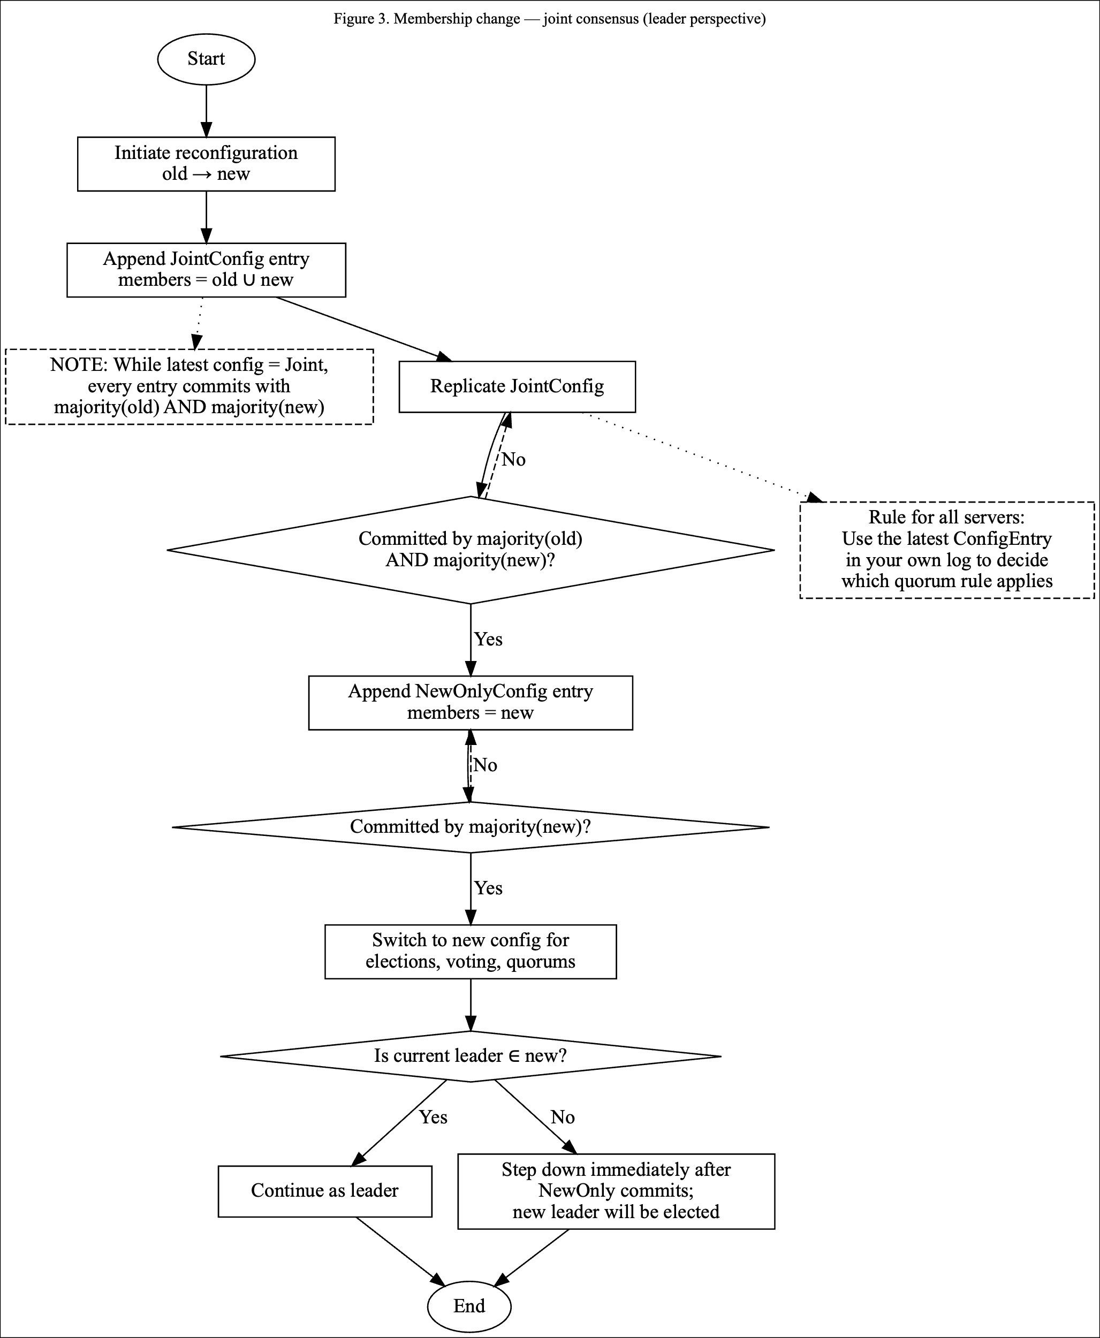
Figure 3: Raft Membership changes

3.2 SWIM

3.2.1 SWIM compared to other algorithms
There are many approaches for maintaining a shared view of cluster membership and detecting failures. The space ranges from probabilistic gossip protocols such as SWIM [5], to accrual detectors such as the Φ-Accrual failure detector [25], and to systems that coordinate stable view changes, such as Rapid [26]. I chose SWIM - Scalable Weakly-consistent Infection-style Process Group Membership - because it offers leaderless operation with constant per-node work and scales smoothly as the cluster grows. SWIM also separates the question of who appears alive from the question of how that information spreads, which keeps the membership plane independent of any durability or total-order requirements.

At a high level, time is divided into short probe intervals. In each interval, a node selects a random peer and pings it. If the ping times out, the node asks a small, fixed number of other peers to send indirect probes to the same target. If those also fail, the target is marked as suspected, meaning it has probably died. SWIM spreads knowledge of joins, leaves, suspicions, and confirmations by attaching a small digest of recent updates to the pings and replies themselves. Every probe or response carries a few pending membership updates with version numbers. When a node receives such a message, it merges the digest into its local view and then passes those updates along with its own in later messages to other nodes. In this way, the same traffic both checks liveness and carries the latest membership state, and the updates continue to circulate until all healthy nodes have seen them. The paper argues for two statistical guarantees. Completeness means every crashed process is eventually suspected by every correct process. Accuracy means no correct process remains suspected forever. These are eventual properties that rely on continued message exchange and are designed to reduce false removals by allowing later refutations when a suspected node responds.

The Φ-Accrual detector models heartbeat inter-arrival times locally and outputs a suspicion level φ. A deployment then chooses a threshold that maps φ to a failure decision that fits its latency profile. This is flexible, but it places threshold selection and distribution-aware tuning on the application, and the detector by itself does not propagate decisions to other nodes. Any cluster-wide membership update needs an external dissemination mechanism [25]. SWIM instead treats suspicion and confirmation as first-class protocol events and attaches small digests of recent membership updates to its ping and ack messages, so detection and dissemination happen together. This also permits refutation: if a healthy node was suspected during a transient delay, it can clear that suspicion once it is heard from again, and that correction spreads through the same gossip. In practice, this design trades immediate unanimous agreement for availability with bounded communication cost. During a brief delay or packet loss, different nodes may temporarily hold different views because some have timed out and marked a slow peer as suspected, while others still consider it alive. SWIM limits per-node overhead by sending only a fixed number of probes per interval and by piggybacking compact membership digests instead of broadcasting to all nodes. When messages resume, the suspected node replies, its refutation circulates, suspicion timers expire, and within a few probe rounds, the cluster converges back to a single view.

Compared to Rapid, SWIM targets eventually consistent membership, while Rapid targets coordinated, unanimous view changes. Rapid aggregates alerts from multiple observers, detects correlated failures such as one-way reachability or rack-local network issues, and converts that evidence into one view change that every node adopts together. This produces very stable membership when the network is one-way or flaky, but it adds agreement logic around each transition [26]. SWIM takes a different stance. It maintains membership through decentralized gossip and periodic probes, so the system keeps operating even if nodes briefly disagree about a peer’s status, and the view converges as updates propagate and suspicions are refuted. For this thesis, I run on a single host and small LAN clusters, so the kinds of network problems Rapid is designed for do not show up, and its benefits would not be visible.
SWIM’s gossip design is widely used in production systems. HashiCorp Consul [17] uses a SWIM-derived gossip layer [27] for node membership and liveness, alongside Raft for consistent leadership and KV operations, as mentioned in Section 3.1.1. Prometheus Alertmanager [28] clusters use memberlist [29], HashiCorp’s implementation of SWIM, to form a High-Availability mesh and gossip user-created mute rules, and the notification log between peers [30]. Grafana Mimir [31] uses memberlist again, but as a gossip-based KV and membership layer to share hash-ring state across instances [32].

3.2.2 SWIM’s inner workings
All of the information in this section is derived from Das, Gupta, and Motivala’s paper [5]. SWIM deliberately separates failure detection from membership dissemination. Liveness is tested by a lightweight, randomized probe protocol. Membership changes are then piggybacked on those probe and reply messages so that updates spread in an epidemic-style without extra broadcast traffic. This yields two key properties emphasized by the paper. The expected time to first detection of a crash does not grow with group size in expectation, and the expected per-member message load remains stable as the cluster grows. Convergence of the membership view follows the same infection curve as classic gossip dissemination. In each protocol period, a node sends at most a constant number of messages: one direct PING and, only on timeout, a small fixed number of PING-REQ requests to helpers. The piggyback digest is also bounded in size. As a result, the per-node messaging and processing cost is O(1) with respect to the cluster size, while total system traffic per period is O(N).

Time is divided into short protocol periods. In each period, a node chooses a random peer and sends a PING. If an ACK arrives within the timeout, the target is considered alive. If no ACK is received, the node chooses a small, fixed set of helper nodes and asks them to perform indirect probes with PING-REQ. If none of the helpers can elicit an ACK from the target within the indirect timeout, the target is marked Suspected. Suspicion does not remove the target. It is a holding state that avoids premature decisions during delay or packet loss. If the suspected node later speaks, the suspicion is cleared. If the suspicion timer expires first, the node becomes Confirmed-failed and is removed from the view. The constants that bound this work are the number of indirect helpers and the digest budget, so the node’s effort per period does not increase with N. The probe and indirect verification sequence is illustrated as a standard flowchart in Figure 4.
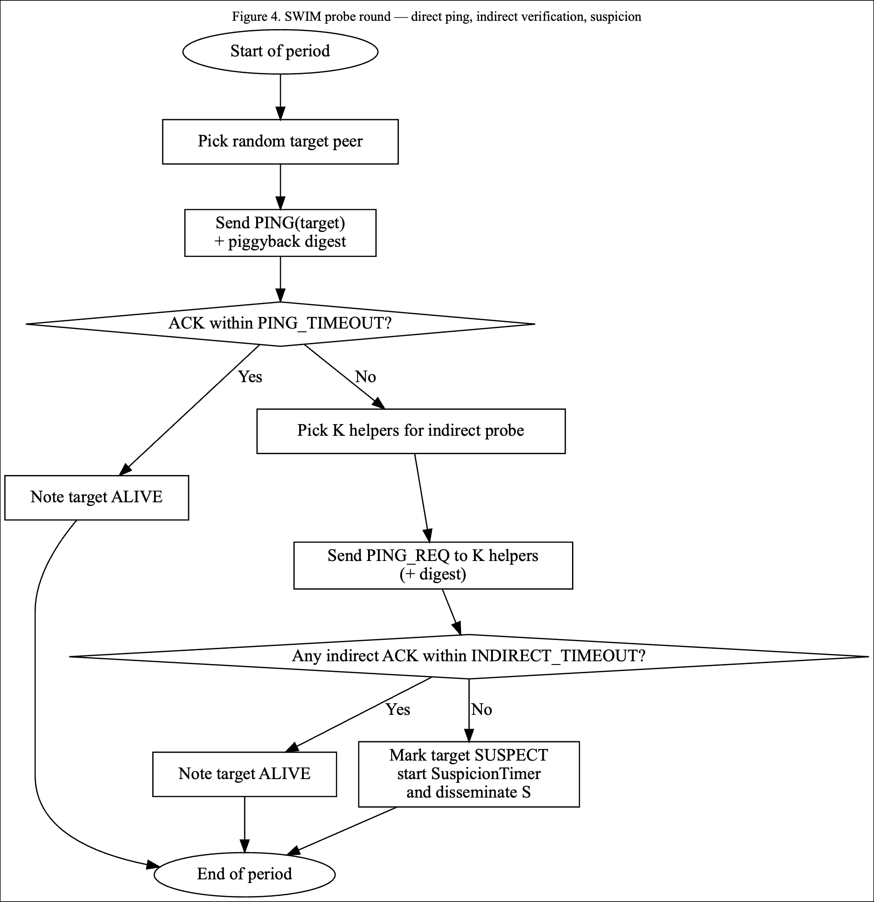
Figure 4: SWIM direct and indirect probe
SWIM uses four types of control messages. A PING checks liveness of a target. An ACK confirms that the recipient is alive. A PING-REQ asks a helper to probe a third node on the sender’s behalf. The helper then sends its own PING to the target and arranges for the target’s ACK to be relayed back to the original requester, either directly to the origin or via the helper as an indirect ACK. Every control message carries a compact digest of recent membership updates. A digest is a bounded list of tuples of the form <memberID, status, incarnation> and represents what the sender currently believes. The receiver merges these tuples into its local table and includes its freshest items in later messages so that updates continue to circulate until the whole cluster has seen them.

Each member is tracked in one of a small set of statuses. Alive means the member is healthy. Suspect means the member might have failed but has not been removed because the suspicion may be due to delay or loss. Confirmed-failed means the cluster has given up waiting for the member and has removed it from the active view. Some implementations also include Left for voluntary departures. The protocol moves entries monotonically from Alive to Suspect to Confirmed-failed unless refuted by fresher evidence of liveness.

To order updates and allow a healthy member to overrule stale suspicion, SWIM tags each member with a virtual incarnation number. This is a per-member counter. When a member learns it is being suspected, it increments its own incarnation and announces Alive with the higher incarnation. Receivers prefer the tuple with the higher incarnation when they merge digests. This simple rule ensures that a later Alive with a higher incarnation refutes an earlier Suspect or Confirmed-failed with a lower incarnation. The correction then propagates through the same piggybacked updates and repairs temporary disagreement without a coordinator. The suspicion lifecycle - with refutation by higher incarnation or confirmation on timeout is visualized in Figure 5.
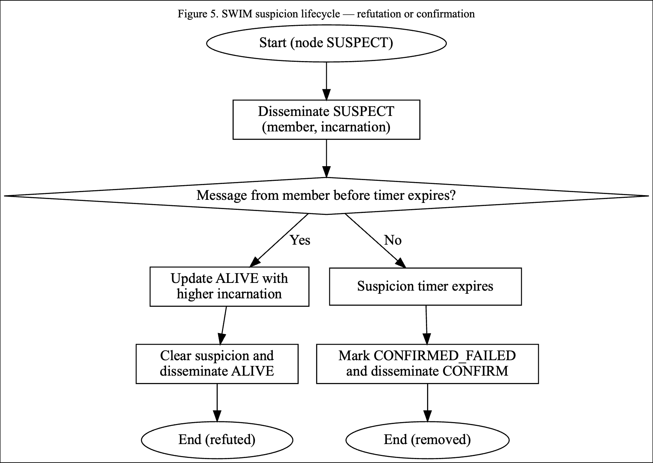
Figure 5: SWIM suspicion lifecycle

SWIM does not rely on IP multicast and does not inject separate broadcast packets for view changes. Each outbound PING, PING-REQ, ACK, and indirect ACK carries a small digest budget. When the budget is full, younger updates are favored so that recent changes spread first. This keeps per-node traffic stable and accelerates convergence after joins, leaves, or failures. Because both the number of helpers and the digest budget are fixed constants, piggybacking preserves the O(1) per-node cost even as the group grows.
With purely random targets, the expected time to first detection of a crash is constant in the number of probes per member, but unlucky draws can delay probing a specific failed node. The paper describes a simple variant that makes detection time deterministically bounded. Each node keeps a locally randomized list of peers and probes in round-robin order, periodically reshuffling. This bounds the gap between successive probes of any target and tightens the worst-case detection time.

The base protocol provides strong completeness. Every crashed process is eventually suspected by every correct process. It also provides eventual accuracy. No correct process remains suspected forever. These guarantees rely on continued message exchange. They are achieved by combining suspect-first handling, incarnation-based refutation, and piggyback dissemination that keeps updates circulating until all correct nodes have seen them.

3.3 Fixed-Sequencer Total Order Broadcast (TOB)

3.3.1 Fixed-Sequencer TOB compared to other algorithms
All of the discussion in this subsection follows the taxonomy in Defago, Schiper, and Urban’s survey on total-order broadcast and multicast algorithms [4]. A fixed-sequencer design has one designated process that assigns a single increasing number to every message. A sender first transmits its message to the sequencer. The sequencer stamps the next number and rebroadcasts an ORDER to the whole group. Each receiver delivers messages only when it holds the next number in sequence and buffers any gaps. In steady state on a LAN the path is simple and predictable: one hop to the sequencer and one hop back to everyone. The guarantee you get is uniform total order and integrity. All correct processes deliver the same set of messages in the same order, and only messages that were actually broadcast are ever delivered. Liveness depends on the sequencer. If it is up and reachable, delivery keeps going. If it fails, ordering pauses until an external mechanism restarts or reassigns the role. Throughput is limited by the sequencer’s outbound bandwidth, which becomes the bottleneck as the group grows. This small core is exactly what makes fixed-sequencer useful in a thesis setting where the goal is to show atomic broadcast as an ordering service by itself, without mixing in quorum logic or reconfiguration machinery [4].

When compared to a moving-sequencer design, a moving sequencer keeps the same basic rule as fixed-sequencer: at any moment one process assigns the next sequence number and everyone delivers in that order. The difference is that the role can change hands, either because the current sequencer fails or because the system chooses to rebalance. When a change happens there is a short, explicit handoff so the new sequencer learns “what is the next unused number” and no number is reused or skipped. During this handoff, senders either pause or keep sending while receivers buffer, and the system resumes once the new sequencer starts stamping numbers again. In steady state the data path looks identical to fixed-sequencer. The gain is higher availability because the coordinator is not a permanent single point. The cost is the extra mechanism around detecting the old sequencer’s failure, picking a successor, and transferring the counter safely so the global order remains a single sequence [4].

Compared to privilege (token) - based algorithms. In token systems a special message - the token - circulates around the group. Only the process holding the token is allowed to assign order and multicast. This enforces a single total order without a fixed coordinator and naturally spreads the right to send across members. What changes is the delay pattern. A sender that has data must wait until the token reaches it. If the token is close, latency is low. If the token is far away, the sender waits even though the network would otherwise carry the traffic. Practical designs batch multiple messages while they hold the token to improve throughput, and they include logic to detect a lost token and regenerate exactly one new token. When the token rotates quickly and loss is low, throughput and fairness can be excellent. When the token lingers elsewhere or the ring needs repair, ready senders wait in line. Fixed-sequencer avoids token management and gives constant two-hop latency when the coordinator is healthy, at the expense of concentrating the outbound traffic on one machine [4].

Compared to communication-history and virtual-synchrony approaches. These protocols avoid a permanent sequencer altogether. They attach causal or timestamp metadata to messages and coordinate views of group membership. Messages are delivered when they are known to be stable for the current view. When the membership changes, a new view is installed in a coordinated way so all processes agree which messages belong to which view. This design exploits concurrency well: independent messages can be in flight at the same time, and the system does not serialize everything through one coordinator. The trade-off is more control information per message and careful view-change handling. To keep delivery atomic, the protocol must flush or finalize messages at each view boundary and ensure that all correct processes make the same decision about what was delivered in that view. Fixed-sequencer trades that generality for a tiny core: one place assigns numbers, receivers buffer gaps, and view logic can be kept outside the ordering path [4].

Compared to consensus-based atomic broadcast. Consensus-based total order - for example Paxos-style atomic broadcast or ZooKeeper’s [33] primary - backup protocol Zab [34] - achieves a single sequence by running agreement rounds over a majority. In ZooKeeper, Zab has the leader propose the next position, a quorum of followers acknowledges, and only then do replicas deliver and commit. This couples ordering with durability and leadership, so the system can keep going as long as a majority is connected and committed entries survive leader changes and crashes. The cost is more messages per decided batch, extra hops through the quorum, and usually a write to stable storage before acknowledging. Many state-machine systems choose this path because they need those stronger fault-tolerance and durability guarantees. A fixed sequencer focuses narrowly on ordering. It produces the same delivery order at all correct processes but leaves majority commitment, persistence, and reconfiguration to other components [4].

3.3.2 Fixed-Sequencer TOB inner workings
As mentioned above in Section 3.3.1, a fixed sequencer assigns a strictly increasing sequence number to every broadcast. A sender calls a local Broadcast function to submit its payload to the sequencer component. The sequencer assigns the next sequence number and publishes an ordered notification to all participants through the transport. Each receiver keeps a pointer to the next expected number and a small hold-back map. A receiver delivers only when it holds exactly the next expected number; larger numbers are kept until the gap is filled. On a LAN the steady-state path is a submit to the sequencer and a publish from the sequencer to everyone else. Safety is straightforward: with at most one active sequencer, all correct processes deliver the same set of items in the same order. Liveness depends on the availability of the sequencer. In this project the sequencer is static; if it fails, ordering pauses. The core data structures and local state are shown in Code Fragment 3.
/* Core data structures (conceptual) */

struct Order {
seq : uint64
id : UUID
payload : bytes
}

/* Local state */

state Sequencer {
seqCtr : uint64 // last issued sequence number
}

state Receiver {
nextSeq : uint64 // sequence expected next for delivery
holdback: map<uint64, Order> // out-of-order buffer keyed by seq
}
Code Fragment 3
The broadcast path appears in Code Fragment 4, and the overall sequencing flow is summarized in Figure 6.

/* Sender API */

procedure Broadcast(payload):
submitToSequencer(payload) // hand off to sequencer component

/* Sequencer behavior */

on sequencerReceive(payload):
seqCtr := seqCtr + 1
order := Order{ seq=seqCtr, id=newUUID(), payload=payload }
publishToAll(order) // transport delivers to all participants
Code Fragment 4
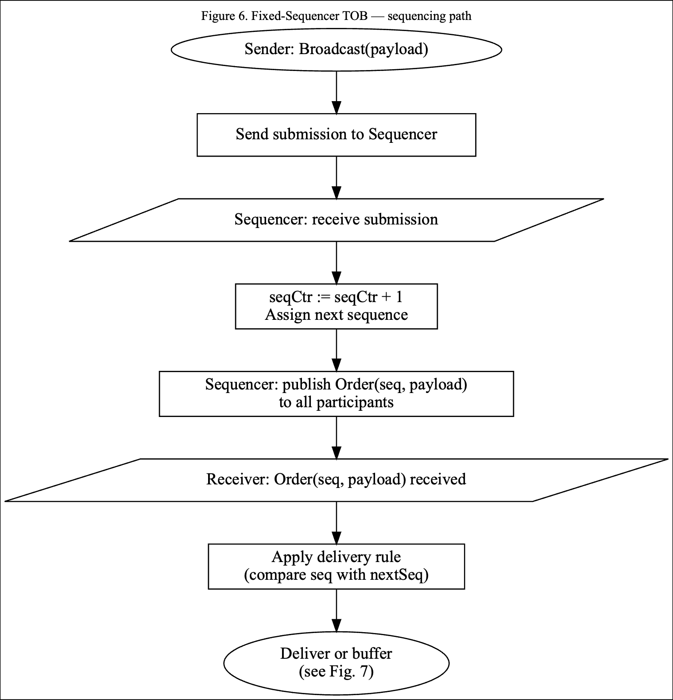
Figure 6: Sequencing Flow
The receiver’s delivery rule is given in Code Fragment 5, with the corresponding state machine in Figure 7.
on orderReceived(order):
if order.seq < nextSeq:
// already delivered; ignore
return

if order.seq == nextSeq:
deliver(order.payload)
nextSeq := nextSeq + 1

// drain any contiguous buffered items
while holdback contains nextSeq:
deliver(holdback[nextSeq].payload)
remove holdback[nextSeq]
nextSeq := nextSeq + 1
else
// order.seq > nextSeq: gap observed; retain until missing numbers arrive
holdback[order.seq] := order
Code Fragment 5
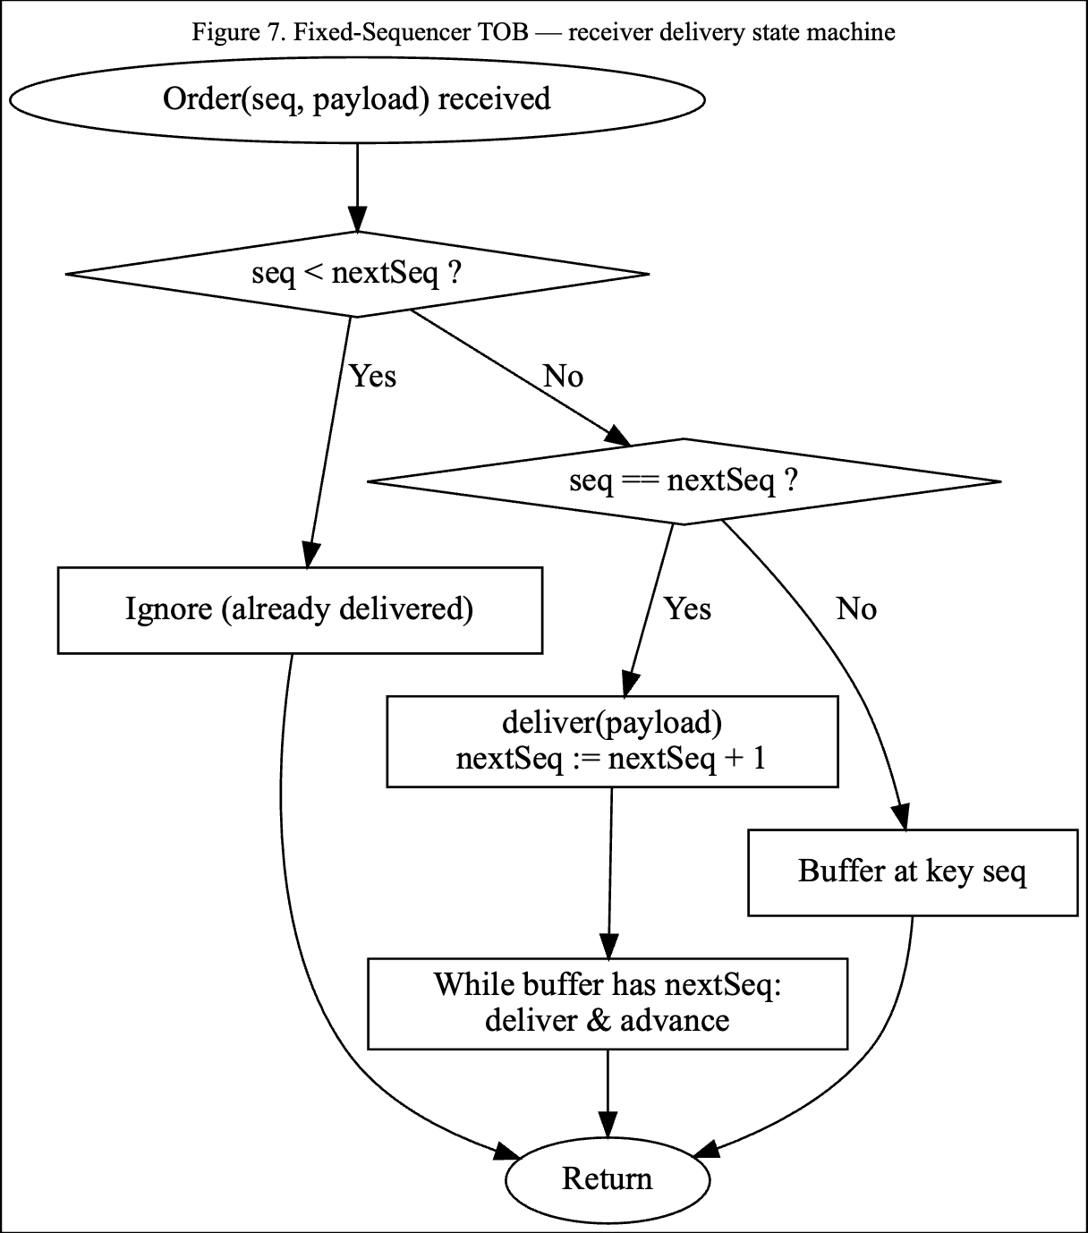
Figure 7: Fixed-Seqencer TOB State Machine

4. Implementation
4.1 Raft
This section describes the specific architectural components, as well as the external libraries used to implement the Raft protocol. For Raft I have managed to achieve a 40.2% Unit test coverage. This is because I couldn’t manage to overcome deadlocking problems that were happening when I was testing the component in isolation.

4.1.1 External Dependencies
As per Go’s philosophy, which states that we should strive to use only the Standard Library and the Project guidelines. I have tried to use as little external dependencies as possible in order to implement the whole algorithm. As Raft relies on a network transport (RPC) and external storage, it made sense to use external dependencies for those parts of the protocol, as implementing RPC or a database which provides atomicity, consistency, isolation, durability (ACID) properties is a senior thesis on its own. The libraries used are as follows: gRPC (google.golang.org/grpc), bbolt (go.etcd.io/bbolt), and google/uuid (github.com/google/uuid).
GRPC was used for the transport layer of Raft. It is based on TCP and more precisely it is using version 2 of the Hypertext Transfer Protocol (HTTP/2). It handles serialization and deserialization of payloads via Protocol Buffers (protobuf), which is Google’s lightweight mechanism for serializing structured data. Protobuf provides us with a so called Protobuf compiler, which generates client side stubs and server side skeletons, from the structures we have defined in the .proto file. This generated code provides a developer friendly API and abstracts away the serialization and deserialization of data. It also saves me a ton of boilerplate code to write, so that I can focus only on the core implementation of Raft.

Bbolt is lightweight, embedded transactional key-value store written in Go, which also provides ACID properties. I use it for the persistence of LogEntries in Raft, as well valuable metadata such as the currentTerm and votedFor fields of the Node.
As Go’s Standard Library does not provide a package to generate Universally unique identifiers (UUIDs), I have used Google’s library. Each node in my Raft implementation has a ServerID in UUID format, which is used to resolve the network address of the node in the cluster, via a custom gRPC resolver.

4.1.2 Custom Pub/Sub Architecture
To decouple the transition between states of the nodes from their handling of events, I have implemented a custom, thread-safe Publish-Subscribe (Pub/Sub) system. For the implementation I have used the standard Go channels as the transport of events in the Pub/Sub system. I have also used Go generics to make the payloads received from those channels type-safe which helped me not use type assertions.
The Pub/Sub system allows components such as the Orchestrator to subscribe to specific EventTypes (e.g., ElectionTimeoutExpired, VoteGranted) and react to them in an asynchronous manner.

4.1.3 Architectural Components
The Class Diagram in Figure 8 shows the core components of my Raft implementation, and how they depend on each other.
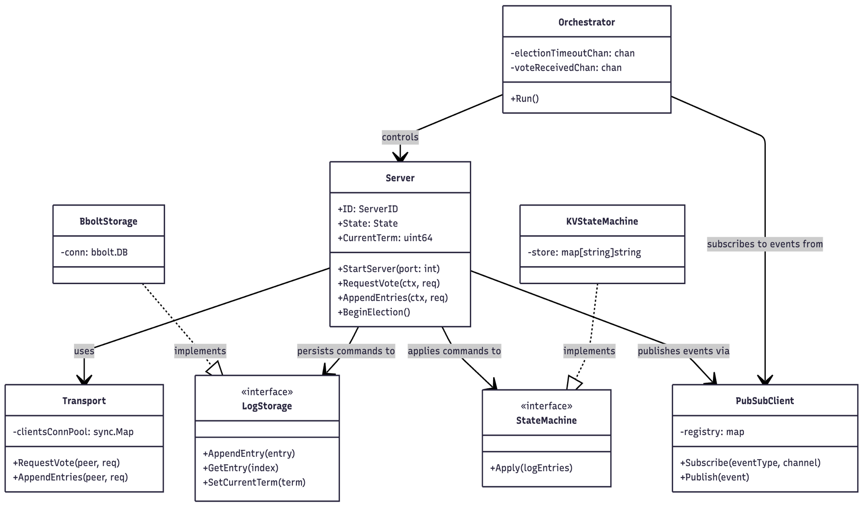
Figure 8: Raft Class Diagram

4.2 SWIM
This section talks about my implementation of the SWIM protocol. For SWIM I have managed to achieve a 89.3% Unit test coverage.

4.2.1 External Dependencies
Similar to Raft, I have used external dependencies for the Transport layer and serialization of data. All of these packages used are part of Go’s Standard Library.
As SWIM uses UDP as transport I have used the standard net package for that, and I have used JSON as the serialization format, as I was more familiar with it, when compared to protobufs as a standalone implementation, meaning not coupled with the gRPC logic. For JSON encoding and decoding I have used the standard encoding/json package.

4.2.2 Architectural Components
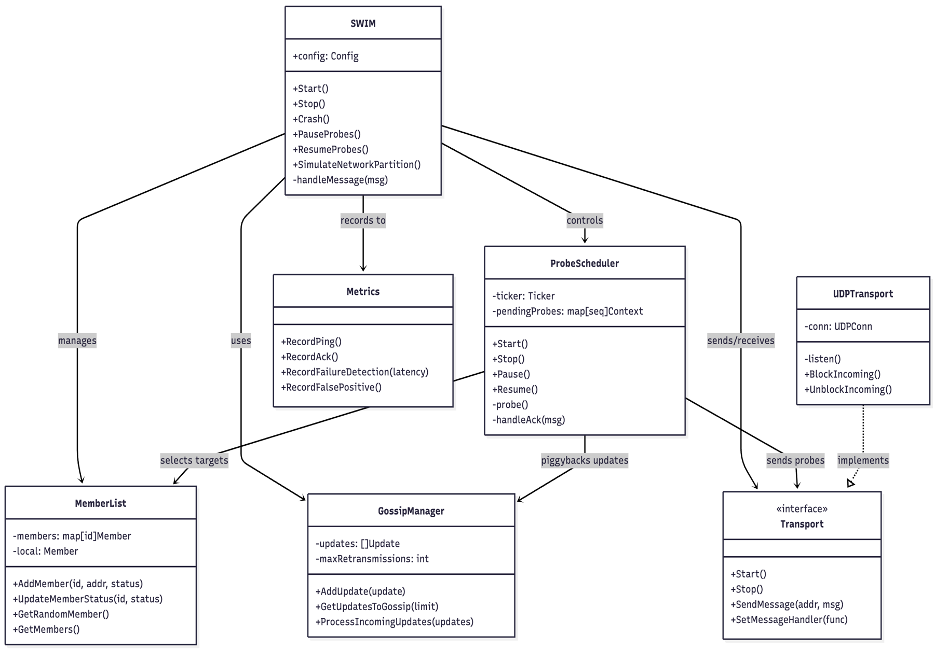
The Class Diagram in Figure 9 shows the core components of my SWIM implementation, and how they depend on each other.
Figure 9: SWIM Class Diagram

4.3 Fixed-Sequencer TOB
This section talks about my implementation of the Fixed-Sequencer Total Order Broadcast.

4.3.1 External Dependencies
As in SWIM I have used Go’s Standard Library net package. I have again used UDP, as the paper assumes “lossy channels” for a Fixed Sequencer implementation. I have also used the container/heap package from the Standard Library, as a priority queue that buffers incoming out of order messages. And finally I have again used Google’s UUID library used in my Raft implementation but this time to generate unique identifiers for MessageIDs, which allows nodes to have idempotent handlers.

4.3.2 Architectural Components
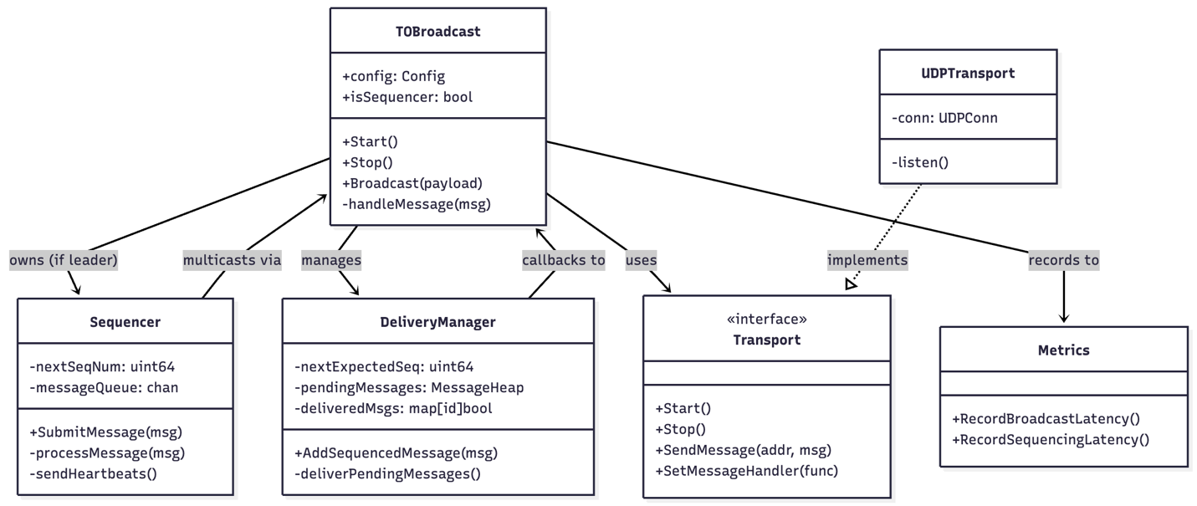
The Class Diagram in Figure 10 shows the core components of my Fixed-Sequencer TOB implementation, and how they depend on each other.

Figure 10: Class Diagram Fixed-Sequencer TOB

5. Benchmarks

5.1 Raft Benchmarks
To evaluate the implementation against the Non-Functional Requirements defined in Section 2.2, I have ran a series of benchmarks running on localhost against a cluster size of nodes N, where N in {3, 5, 7, 9}. The benchmarks tried to evaluate Performance (NFR1) and Scalability (NFR2), as the cluster size N grew from 3 to 9. The results presented in this section represent an aggregation of three independent test runs of the benchmarking suite.
For each run and each cluster configuration, a workload of 200 commands was submitted sequentially to the leader node in the cluster, i.e. for a cluster size of 3 nodes, 200 commands were submitted, for a cluster size of 5 nodes, 200 commands were submitted, etc. This volume was chosen to ensure the system reached a steady state of operation, allowing for the observation of both normal replication behavior and occasional stochastic events such as election timeouts or garbage collection pauses.

5.1.1 Raft Performance Analysis (NFR1)
The primary performance indicators measured were Throughput, defined as the number of client commands the cluster successfully commits per second (FR3). Latency percentiles (p50, p95, p99) measure the time from when a client submits a command until the command is committed by the majority of nodes (and therefore safe to apply in order on each replica’s state machine). The aggregated results of the 3 runs are shown below in Table1.
Table 1: Aggregated Raft Performance Metrics (Average of 3 Runs)
Cluster Size | Throughput (cmd/s) | P50 Latency (ms) | P95 Latency (ms) | P99 Latency (ms) | Mean Latency (ms)
3 nodes | 8.73 | 170.60 | 265.51 | 377.37 | 191.18
5 nodes | 9.20 | 173.95 | 255.48 | 301.78 | 172.08
7 nodes | 9.02 | 168.49 | 266.45 | 301.52 | 171.24
9 nodes | 8.52 | 167.77 | 272.66 | 302.97 | 172.97

The median (P50) latency remained remarkably stable across all cluster sizes, hovering consistently around 170ms. This baseline latency represents the minimum expected time for a commit cycle in this test environment. Given that my implementation employs immediate parallel replication as per Section 5.3 from the Raft paper (sending AppendEntires RPC to peers when a command is received by the leader, rather than waiting for heartbeats [3]), this latency floor is dominated by the cost of writing to durable storage.

As mentioned in Section 4.1.1 my implementation uses bbolt (BoltDB) [35], a transactional key-value store written in Go that guarantees ACID properties, for the persistent log storage required by Raft [1]. Each log entry must be synchronously flushed to disk (fsync) to guarantee durability before it can be acknowledged. A successful Raft commit requires this operation to complete sequentially on multiple nodes: first on the leader to persist the incoming command, and subsequently on a majority of followers before the whole Log Replication operation can be acknowledged. The cumulative duration of these synchronous I/O operations, combined with the network round-trip time, defines the 170ms floor.

In a standard Raft implementation, a command is committed once it is replicated to th majority of nodes in the cluster. As the cluster size N increases, the size of this required quorum grows. For a 3-node cluster, the leader needs acknowledgment from only 1 follower (plus itself). For a 9-node cluster, it needs acknowledgments from 4 followers.

But because the leader node issues AppendEntries RPCs in parallel to all follower nodes, the commit latency is determined by the response time of the fastest majority subset of followers. The leader does not need to wait for the slowest nodes; it only needs the fastest 4 out of 8 followers to reply. By doing so this mechanism effectively disregards the latency of slower peers, and ensurs that performance does not degrade linearly as the cluster size grows.

While median performance was stable, the tail latencies (P95 and P99) exhibited notable variability. The peak P99 latency of 377ms observed in the 3-node cluster is particularly interesting. This high outlier is likely a result of the smaller quorum size making the system more sensitive to individual node delays.

In a 3-node cluster, the quorum requires 2 nodes. If the leader is fast, it still absolutely requires a response from one specific follower (assuming the third is slower or busy). If that specific follower experiences a transient delay - such as a Go Runtime Garbage Collection (GC) "stop-the-world" pause, where all goroutines are paused during the mark and sweep phases of the GC, the entire commit is stalled. This is because my implementation spawns each server as a separate goroutine withing the single Go process that is running (my application). A single GC mechanism manages the entire process. When it triggers a "Stop-the-World" pause, it pauses all goroutines in that process simultaneously, meaning Leader, Follower 1, and Follower 2 and all other goroutines responsible for sending and handling request.

In contrast, for larger clusters (N=9), the P99 stabilizes around 300ms. This data suggests that while larger clusters generate more traffic across the system, they provide a form of "tail tolerance." This is because as the cluster is larger, it requires a larger majority which minimizes the chance of 1 or 2 slow nodes slowing down the whole process, as it could happen in smaller cluster sizes.

Throughput for the system remained relatively consistent, averaging between 8.5 and 9.2 commands per second. While this may seem quite low when compared to production databases, but it is important to provide some context against the test methodology. The benchmark client operated in a synchronous mode, meaning it was submitting a new command to the leader, only after receiving an acknowledgement from the leader that the previous command was appended to its local log.

5.1.2 Raft Scalability Analysis (NFR2)
To analyze Scalability, I have tracked the total number of RPCs send and the number of elections as the cluster grew. The results are summarized in Table 2 below.

Table 2: Raft Scalability Metrics: RPCs and Elections count (Average of 3 Runs)
Cluster Size | Total RPCs | AppendEntries | Heartbeats | Election count
3 nodes | 1966 | 400 | 1,566 | 3.3
5 nodes | 3247 | 800 | 2,447 | 4.0
7 nodes | 4815 | 1,203 | 3,612 | 11.3
9 nodes | 6611 | 1,600 | 5,011 | 12.3

The Total RPCs metric demonstrates a clear linear growth trend relative to the cluster size. In the largest cluster size (N=9), the leader node handled approximately 6,611 RPCs over the duration of the benchmark. This is roughly 3.36x the load of the smallest cluster size of N=3 where 1,966 RPCs were handled.

This data shows that the network load in a Raft cluster is O(N). For every heartbeat interval, the leader broadcasts N-1 messages. As N increases, the leader's outbound bandwidth and its CPU capacity, essentially become the scalability bottleneck of the system. Because Raft has a strong consistency model, this centralized communication through the leader node limits its scalability (when we compare it to eventually consistent models such as SWIM).

The increase of elections, as N grows, shown in the Election indicates a stability challenge that arises when the cluster grows. The 3-node and 5-node clusters were quite stable, averaging only 3-4 elections per run, the 7-node and 9-node clusters, on the other hand, saw a drastic increase in elections (over 11 elections on average).

This is probably due to the design of the event processing loop within the Orchestrator. The orchestrator is implemented as a single goroutine that consumes events sequentially from multiple Go channels using the select statement. This means that it handles signals such as VoteGranted and ElectionTimeoutExpired one at a time.

As the cluster size increases, the volume of incoming request, and in particular the RequestVote responses from clients increase, which is expected. In a 9-node cluster, a single election generates a spike of concurrent RequestVote responses. Yes each of these request is handled in a separate Go routine via the running gRPC server, but in the handler of this RPC a VoteGranted signal is sent via the PubSub client, which the Orchestrator has subscribed to listen to. As the orchestrator processes these signals sequentially, and the function responsible for processing such events involves acquiring a lock on the main Server struct, a backlog of events can form. If the orchestrator is blocked waiting for a lock or processing a queue of votes, it delays the processing of the ElectionTimeoutExpired signal from the background job that tracks the ElectionTimeout. This potential head-of-line blocking in the event loop introduces latency, and due to it a server’s election timer might technically time out according to the system clock, but the orchestrator will not process that timeout signal until after it has finished its current work. This leads to delayed state transitions that probably result in the election instability. For larger clusters, this suggests that the current event processing architecture may need to be further decoupled in the future to prevent the starvation of critical election timeout signals.

5.2 SWIM Benchmarks
For SWIM, similar to Raft the benchmark suite was run against cluster sizes where N, the number of nodes is in {3, 5, 7, 9}. To test the system, while adhering to membership semantics (FR5), I ran two separate benchmark suits – one for crash-stop failures of nodes and one for network partitions.

In the Crash-Stop scenario nodes are forcibly terminated via a SIGKILL Unix signal. This evaluated the Completeness guarantee of SWIM which states that all crashed nodes will eventually be detected. The Network Partition tests evaluated SWIM’s accuracy (resistance to false positives) and the protocol's Refutation mechanism. The results presented below represent are again an aggregation of three independent test runs for each scenario.

5.2.1 SWIM Performance Analysis (NFR1)
The primary performance indicator for the SWIM protocol is Probe Latency. This is measured by the round-trip time for a successful PING and ACK exchange between two healthy nodes. The results are shown in Table 3 below.
Table 3: Aggregated SWIM Performance Metrics (Average of 3 Runs)
Cluster Size | P50 Latency (ms) | P95 Latency (ms) | Mean Latency (ms)
3 nodes | 1.07 | 1.85 | 1.12
5 nodes | 1.00 | 2.35 | 1.16
7 nodes | 1.01 | 2.25 | 1.13
9 nodes | 1.17 | 2.66 | 1.33

The median (P50) probe latency remained consistently low, averaging approximately 1.1ms. This validates the O(1) complexity claim, as a node probes only one peer per interval, assuming no indirect pings, but even with those is it again roughly const.

The magnitude of this latency (~1ms) is due to the fact that these tests are running on localhost and SWIM uses UDP as a transport protocol. Since packets travel over the loopback interface, the measured time primarily reflects the OS kernel's context switching speed and the implementation of the UDP protocol by Go’s Standard Library. The stability of this metric shows that the protocol adds a negligible processing overhead as the cluster grows.

Failure Detection Latency measures the time that has elapsesd between a node's main process crashing and the moment when another node marks it as Suspected. The results are shown in Table 4 below.

Table 4: Aggregated Failure Detection Latency (Average of 3 Crash-Stop Runs)
Cluster Size | P50 Detection (ms) | P95 Detection (ms) | Mean Detection (ms)
3 nodes | 1,098 | 2,045 | 1,190
5 nodes | 1,005 | 2,412 | 1,252
7 nodes | 1,064 | 2,462 | 1,183
9 nodes | 1,154 | 2,656 | 1,399

The data shows detection times averaging between 1.2s and 1.4s. This validates FR5 (Completeness) as it confirms that crashed nodes are detected within the bounds of the timeouts for the pings.
Latency is a function of the protocol configuration where the ProbeInterval was set to 1 second and ProbeTimeout 0.5s. When a node crashes, it will eventually be selected as a probe target by a node from the cluster. Once the crashed node is probed, it will fail to respond, and after the ProbeTimeout of 0.5s expires without an ACK received, the protocol triggers indirect probes. When those also fail (since the node is truly down), the node marks the probed target as Suspected. The average of ~1.3s shows that failure detection does not degrade linearly as the cluster grows.

5.2.2 Scalability Analysis (NFR2 & FR6)
Scalability was evaluated by tracking the network traffic generated by the protocol as the cluster size increased. FR6 (Dissemination cost) mandates that the network load per node must remain constant, meaning it should not increase linearly with the cluster size N.
Table 5: SWIM Scalability Metrics: Message Load (Average of 3 Crash-Stop Runs)
Cluster Size | Total Messages | Throughput (msg/s) | Messages/Node
3 nodes | 1,188 | 9.50 | 198.8
5 nodes | 2,247 | 18.00 | 226.8
7 nodes | 3,262 | 26.10 | 234.0
9 nodes | 4,268 | 34.14 | 237.4
In these tests, as the cluster size tripled from 3 to 9 nodes, the message load per node did not triple, it plateaued around ~237 messages. The difference between the smallest cluster (N=3) of 198 messages per node is due to the fact that in such small clusters updates are almost instant as they require fewer rounds trips of piggybacking. From 5 nodes and above the protocol stabilized, resulting is some sort of a predictable and bounded load. This confirms that the implementation satisfies FR6.

In the partition tests, a node was isolated for 10 seconds. This network partition duration intentionally exceeds the configured SuspicionTimeout of 5 seconds. When the partition starts, peers correctly detect that node is unreachable and mark it as Suspected, but because the partition lasts 10s, which is longer than the configured 5s timeout, the suspicion timeout expires, and the cluster eventually marks the node as Failed. When the partition is restored, the node which was isolated and is still running sends a message, and the cluster sees a message from a Failed node which per the SWIM paper means a False Positive, as a healthy process was marked as Failed.
The data shows a non-zero False Positive Rate (FP Rate) for larger clusters, ranging from 8.5% to 34%. This behavior shows the trade-off which SWIM makes, prioritizing Availability over Consistency. The results are shown in Table 6 below.
Table 6: Failure Detection Accuracy under Network Partition (Average of 3 Runs)
Cluster Size | Suspicions Raised | Refutations (Success) | False Positives (Failure) | FP Rate
3 nodes | 2.7 | 0.0 | 0.0 | 0.00%
5 nodes | 10.3 | 1.3 | 1.3 | 8.57%
7 nodes | 22.0 | 14.0 | 8.0 | 34.17%
9 nodes | 29.7 | 8.3 | 2.7 | 20.30%

5.3 Fixed-Sequencer Total Order Broadcast (TOB) Benchmarks
For the Fixed Sequencer TOB the setup was again a cluster size where N, the number of nodes in the cluster was in {3, 5, 7, 9}, running on localhost. Again the results are an average of three independent runs of the benchmark suite. Each run of the benchmarking suite involved broadcasting a continuous stream of messages to the sequencer, in order to measure its ordering capacity (throughput), and the resulting delivery latencies after the messages have been stamped with a sequence number and then delivered.

5.3.1 Fixed-Sequencer TOB Performance Analysis (NFR1)
For the performance measurements I considered throughput, the delivery latency mentioned above. The results are presented in Table 7 below:
Table 7: Aggregated TOB Performance Metrics (Average of 3 Independent Runs)
Cluster Size | P50 Latency (ms) | P95 Latency (ms) | P99 Latency (ms) | Throughput (msg/s) | Seq Latency (ms)
3 nodes | 0.69 | 1.59 | 2.51 | 104.58 | 0.29
5 nodes | 0.88 | 2.24 | 3.41 | 173.66 | 0.63
7 nodes | 0.90 | 2.55 | 3.65 | 243.30 | 0.86
9 nodes | 1.03 | 2.61 | 3.55 | 312.98 | 1.01

The P50 delivery latency remained consistently below 1.1ms for all cluster sizes, and for the 3-node cluster we had a sub-millisecond latency (~ 0.69ms). When compared to Raft\s ~170ms , this is significantly faster, which is expected. For the Fixed-Sequencer TOB I have chosen UDP as a protocol transport, while Raft uses TCP, and TCP adds the overhead of TCP handshakes. We also don’t have writes to disk.

Fixed-Sequencer TOB Scalability Analysis (NFR2)
While the current results show excellent performance, this architecture has a scalability limit defined by FR8 (Sequencer Availability). In a Fixed-Sequencer algorithm, the sequencer is a single point of congestion, as every broadcast must pass through the sequencer which is 1 hop before being sent to the rest of the cluster which is N hops. The sequencer's outbound traffic grows as O(N times R), where R is the broadcast rate and N is the UDP packets it has to send. We observe this limit forming in the Seq Latency metric. It grows from 0.29ms (N=3) to 1.01ms (N=9). This 3.5x increase in processing time shows that as the cluster grows, the sequencer takes longer to serialize and transmit the data to all nodes in the cluster.

5.4 Future Work
As mentioned above the Raft implementation could be revisited in order to increase the stability during the election process, when the cluster size increases. This could probably be achieved via a concurrent handling of events, rather than using the select statement for Go channels. We could also take the approach of HashiCorp, where for their implementation [36] they are handling everything in a single goroutine and minimize the burden of thinking about locks.
For SWIM, an approach to improve the False Positive Rate could be inspired from HashiCorp’s Lifeguard [12] and we could dynamically increase the timeout windows when multiple nodes simultaneously suspect the same node, which could suggest a network partition, as all paths to this node have disappeared at the same time.

6. Results and Conclusion
This section summarizes the findings from the implementation and benchmarking of the three coordination mechanisms: Raft, SWIM, and Fixed-Sequencer TOB. As mentioned in the Introduction section, the results will be analyzed under the CAP theorem, evaluating the trade-offs each algorithm makes between Consistency (C), Availability (A), and Partition Tolerance (P). Finally, I will give recommendations on when to select a given protocol based on different system requirements.

6.1 Raft: Strong Consistency at the Cost of Availability

CAP Theorem Analysis
Raft is designed as a CP (Consistency + Partition Tolerance) system. It guarantees that all committed data is consistent across a majority of nodes, even if a network partition arises. The benchmark results in Section 5.1 confirm Raft's strong consistency guarantees. The median commit latency of ~170ms reflects the cost of synchronous replication to a majority quorum. This latency floor ensures that once a command is committed, it is durable and consistent across all replicas in the majority.
Partition Tolerance is mitigated by design as Raft requires a majority quorum to operate. In case a partition occurs and the majority of the nodes are up, running and reachable, we lose some Availability on the minority side but we maintain Consistency. Availability is also sacrificed during elections. This is because if the leader node happens to become isolated due to the network partition, whichever node’s election timeout expires first, this node will trigger an election. During the election process, the system is unavailable for writes.

When to use Raft
Raft is the ideal choice for the control plane of a distributed system where data integrity and consistency are essential. A good use case is storing critical metadata, configuration settings, or coordination state (e.g., Kubernetes etcd, Consul). This is because the write latency of 170ms is usually acceptable for such metadata updates as we cannot risk a corrupted state of the cluster. Given this Raft should not be used for high-throughput data planes (e.g., log ingestion, metrics) as the leader becomes a bottleneck due to the O(N) load on the network.

6.2 SWIM: High Availability and Scalability

CAP Theorem Analysis
SWIM is designed as an AP (Availability + Partition Tolerance) system. It prioritizes keeping the system operational and responsive over always ensuring a strictly consistent view of membership across the whole cluster. The benchmarks in Section 5.2 show that even when nodes were crashed or there was a network partition the system remained operational, continuing to gossip updates. Partition Tolerance is achieved by allowing the cluster view to diverge temporarily. This is shown via the benchmarks in Section 5.2.3 where there could be a False Positive Rate of up to 40% during partitions, at least in my implementation. This is the direct cost of this tolerance, the cluster marks unreachable nodes as Failed in order to keep the membership list clean, and in case the nodes go back up again, they positions will be restored later via a refutation. As mentioned multiple times the SWIM provides eventual consistency, meaning during a propagation window of updates, different nodes may have different views of the cluster membership.

When to Use SWIM
SWIM is best suited for membership management and failure detection in large-scale, dynamic systems where scalability and liveness are critical, and temporary inconsistencies in the member list are tolerable. A use case is Peer discovery in peer-to-peer networks, failure detection in large microservice meshes (e.g., HashiCorp’s Serf used in Consul). Its O(1) scalability ensures the network isn't flooded as the cluster grows to thousands of nodes. As SWIM provides only eventual consistency it should not be used as the sole mechanism for tasks requiring a single source of truth, such as distributed locking or electing a global coordinator. Because SWIM allows temporary disagreements about the cluster membership view, relying on it for critical coordination could lead to split-brain scenarios where the cluster makes conflicting decisions based on divergent views, which could result in data corruption.

6.3 Fixed-Sequencer TOB: Throughput and Total Order

6.3.1 CAP Theorem Analysis
The Fixed-Sequencer TOB is designed is CA (Consistency + Availability) system. uitable for high-performance LAN environments where partitions are rare or handled externally.
About Consistency, the system achieves Uniform Total Order (FR7). The Availability part is simple - as long as the sequencer is up, the system works as designed. Thus if it has CA, it cannot tolerate a network partition, as per FR8. The sequencer is a single point of failure, if a network partition happens, and it gets isolated, the entire ordering halts.

6.3.2 When to Use Atomic Broadcast (Total Order Broadcast)
Atomic Broadcast (or Total Order Broadcast) is distinct from Consensus, although they are theoretically equivalent [37], meaning if we can solve one we can automatically solve the other. Consensus focuses on agreeing on a single value, Atomic Broadcast focuses on delivering a set of values in the same order to all nodes. It is best suited for the data plane or active replication of systems where state is deterministic. A great example is the Shared Log Abstractions of CorfuDB [37]. It uses a dedicated Sequencer node to assign 64-bit token addresses to clients. Clients then write their data directly to storage units (Logging Units) at those addresses. This architecture mirrors the Fixed-Sequencer TOB model: the sequencer handles lightweight ordering (metadata), while the heavy data path bypasses it. This allows CorfuDB to achieve massive throughput. Another example is the Active-Active Database Replication of Galera Cluster [38]. Atomic Broadcast is used to serialize transactions across multiple database masters to prevent write conflicts. Galera uses a certification-based replication protocol, where when a transaction is ready to commit, it is broadcast to all nodes. The nodes effectively agree on a global total order for that transaction. If two nodes try to modify the same row at the same, the total order ensures that all nodes consistently accept the first transaction and then reject the second, guaranteeing data consistency across a multi-master cluster.

In conclusion, addressing the complex challenges that arise in distributed systems is rarely achieve via a single monolithic algorithm, more often that not a composition of different protocols is used. A reliable distributed architecture is best achieved by layering these protocols. Namely, SWIM could be used as the scalable foundation for failure detection of nodes. Raft could build on top of this membership layer by providing a strongly consistent control plane for handling critical configuration metadata. And finally, Atomic Broadcast, in this case a Fixed-Sequencer variant, could leverage the stability of the lower layers and enabling the low latency, ordered replication of events, necessary for modern data intensive applications.

References:
[1] “Swarm mode,” Docker Documentation. Accessed: Dec. 02, 2025. [Online]. Available: https://docs.docker.com/engine/swarm/
[2] “Raft consensus in swarm mode,” Docker Documentation. Accessed: Dec. 02, 2025. [Online]. Available: https://docs.docker.com/engine/swarm/raft/
[3] D. Ongaro and J. Ousterhout, “In search of an understandable consensus algorithm,” in Proceedings of the 2014 USENIX conference on USENIX Annual Technical Conference, in USENIX ATC’14. USA: USENIX Association, June 2014, pp. 305–320.
[4] X. Defago, A. Schiper, and P. Urban, “Total Order Broadcast and Multicast Algorithms:∗ Taxonomy and Survey”.
[5] A. Das, I. Gupta, and A. Motivala, “SWIM: scalable weakly-consistent infection-style process group membership protocol,” in Proceedings International Conference on Dependable Systems and Networks, Washington, DC, USA: IEEE Comput. Soc, 2002, pp. 303–312. doi: 10.1109/DSN.2002.1028914.
[6] “The Go Programming Language.” Accessed: Oct. 09, 2025. [Online]. Available: https://go.dev/
[7] K. Penfound, Dagger, C. Nickerson, and Kubeshop, “Production-Grade Container Orchestration,” Kubernetes. Accessed: Oct. 09, 2025. [Online]. Available: https://kubernetes.io/
[8] “Docker: Accelerated Container Application Development.” Accessed: Oct. 09, 2025. [Online]. Available: https://www.docker.com/
[9] R. C. Martin, “Design Principles and Design Patterns,” 2000.
[10] Google for Developers, Google I/O 2010 - Go Programming, (May 29, 2010). Accessed: Oct. 08, 2025. [Online Video]. Available: https://www.youtube.com/watch?v=jgVhBThJdXc
[11] L. Lamport, “Time, clocks, and the ordering of events in a distributed system,” Commun. ACM, vol. 21, no. 7, pp. 558–565, July 1978, doi: 10.1145/359545.359563.
[12] A. Dadgar, J. Phillips, and J. Currey, “Lifeguard: Local Health Awareness for More Accurate Failure Detection,” Apr. 03, 2018, arXiv: arXiv:1707.00788. doi: 10.48550/arXiv.1707.00788.
[13] L. Lamport, “The part-time parliament,” ACM Trans Comput Syst, vol. 16, no. 2, pp. 133–169, May 1998, doi: 10.1145/279227.279229.
[14] L. Lamport, “Paxos Made Simple,” ACM SIGACT News Distrib. Comput. Column 32 4 Whole Number 121 Dec. 2001, pp. 51–58, Dec. 2001.
[15] B. Liskov and J. Cowling, “Viewstamped Replication Revisited”.
[16] “etcd,” etcd. Accessed: Oct. 14, 2025. [Online]. Available: https://etcd.io/
[17] “CockroachDB | Distributed SQL for always-on customer experiences.” Accessed: Oct. 14, 2025. [Online]. Available: https://www.cockroachlabs.com/homepage/
[18] HashiCorp, “HashiCorp Consul | Connect and Secure Any Service,” HashiCorp | An IBM Company. Accessed: Oct. 14, 2025. [Online]. Available: https://www.hashicorp.com/en/products/consul
[19] L. Lamport, D. Malkhi, and L. Zhou, “Vertical paxos and primary-backup replication,” in Proceedings of the 28th ACM symposium on Principles of distributed computing, Calgary AB Canada: ACM, Aug. 2009, pp. 312–313. doi: 10.1145/1582716.1582783.
[20] F. B. Schneider, “Implementing fault-tolerant services using the state machine approach: a tutorial,” ACM Comput Surv, vol. 22, no. 4, pp. 299–319, Dec. 1990, doi: 10.1145/98163.98167.
[21] “TigerBeetle.” Accessed: Oct. 15, 2025. [Online]. Available: https://tigerbeetle.com/
[22] SNIAVideo, SDC 2018 - Protocol-Aware Recovery for Consensus-Based Storage, (Oct. 19, 2018). Accessed: Oct. 15, 2025. [Online Video]. Available: https://www.youtube.com/watch?v=fDY6Wi0GcPs
[23] “tigerbeetle/docs/DESIGN.md at fe09404d465df46b2bdfc017633eff37b4ab2343 · tigerbeetle/tigerbeetle,” GitHub. Accessed: Oct. 15, 2025. [Online]. Available: https://github.com/tigerbeetle/tigerbeetle/blob/fe09404d465df46b2bdfc017633eff37b4ab2343/docs/DESIGN.md
[24] logcabin/logcabin. (Oct. 13, 2025). C++. LogCabin. Accessed: Oct. 15, 2025. [Online]. Available: https://github.com/logcabin/logcabin
[25] N. Hayashibara, X. Defago, R. Yared, and T. Katayama, “The /spl phi/ accrual failure detector,” in Proceedings of the 23rd IEEE International Symposium on Reliable Distributed Systems, 2004., Oct. 2004, pp. 66–78. doi: 10.1109/RELDIS.2004.1353004.
[26] L. Suresh, D. Malkhi, P. Gopalan, and I. P. Carreiro, “Stable and Consistent Membership at Scale with Rapid”.
[27] “Gossip Protocol | Serf | Consul | HashiCorp Developer,” Gossip Protocol | Serf | Consul | HashiCorp Developer. Accessed: Nov. 05, 2025. [Online]. Available: https://developer.hashicorp.com/consul/docs/concept/gossip
[28] “Alertmanager | Prometheus.” Accessed: Nov. 05, 2025. [Online]. Available: https://prometheus.io/docs/alerting/latest/alertmanager/
[29] hashicorp/memberlist. (Nov. 05, 2025). Go. HashiCorp. Accessed: Nov. 05, 2025. [Online]. Available: https://github.com/hashicorp/memberlist
[30] “alertmanager/doc/design/secure-cluster-traffic.md at main · prometheus/alertmanager,” GitHub. Accessed: Nov. 05, 2025. [Online]. Available: https://github.com/prometheus/alertmanager/blob/main/doc/design/secure-cluster-traffic.md
[31] “Grafana Mimir documentation | Grafana Mimir documentation,” Grafana Labs. Accessed: Nov. 05, 2025. [Online]. Available: https://grafana.com/docs/mimir/latest/
[32] “Grafana Mimir memberlist and gossip protocol | Grafana Mimir documentation,” Grafana Labs. Accessed: Nov. 05, 2025. [Online]. Available: https://grafana.com/docs/mimir/latest/references/architecture/memberlist-and-the-gossip-protocol/
[33] P. Hunt, M. Konar, F. P. Junqueira, and B. Reed, “ZooKeeper: Wait-free coordination for Internet-scale systems”.
[34] F. P. Junqueira, B. C. Reed, and M. Serafini, “Zab: High-performance broadcast for primary-backup systems,” in 2011 IEEE/IFIP 41st International Conference on Dependable Systems & Networks (DSN), June 2011, pp. 245–256. doi: 10.1109/DSN.2011.5958223.
[35] etcd-io/bbolt. (Nov. 25, 2025). Go. etcd-io. Accessed: Nov. 25, 2025. [Online]. Available: https://github.com/etcd-io/bbolt
[36] “hashicorp/raft: Golang implementation of the Raft consensus protocol.” Accessed: Dec. 05, 2025. [Online]. Available: https://github.com/hashicorp/raft
[37] T. D. Chandra and S. Toueg, “Unreliable failure detectors for reliable distributed systems,” J. ACM, vol. 43, no. 2, pp. 225–267, Mar. 1996, doi: 10.1145/226643.226647.

